Disclaimer:
COPYRIGHT NOTICE
©All content, materials, and intellectual property contained within this document, including but not limited to text, images, diagrams, graphics, code, and any other original works, are protected by copyright laws and international treaties. This intellectual property is the sole and exclusive property of Ankit Nagar ( @geeky_frontend )
Unauthorized use, reproduction, distribution, modification, or transmission of any portion of this document, in any form or by any means, electronic or mechanical, without the prior written permission of Ankit Nagar ( @geeky_frontend ), is strictly prohibited and may result in severe civil and criminal penalties.

By accessing, viewing, or using this document, you acknowledge and agree to abide by all applicable copyright laws and the terms and conditions outlined herein. This copyright notice serves as a legal warning and reminder that the unauthorized use of this intellectual property is strictly prohibited and will be vigorously enforced.

Thank you for respecting the intellectual property rights of Ankit Nagar ( @geeky_frontend )

DSA for frontend

Patterns in DSA
- Two Pointer
  - Pattern: Utilize two pointers to iterate through an array or list from different ends or with different speeds.
  - Common Problems: Linked List Cycle, Two Sum II, Container with Most Water, 3Sum.
- Binary Tree BFS
  - Pattern: Use a queue to traverse the tree level by level.
  - Common Problems: Binary Tree Level Order Traversal, Minimum Depth of Binary Tree, Binary Tree Zigzag Level Order Traversal.
- Topological Sort
  - Pattern: Use DFS or Kahn’s algorithm to order tasks that depend on other tasks.
  - Common Problems: Course Schedule, Course Schedule II, Alien Dictionary.
- Binary Tree DFS
  - Pattern: Use recursion or an explicit stack to traverse the tree pre-order, in-order, or post-order.
  - Common Problems: Binary Tree Inorder Traversal, Path Sum, Maximum Depth of Binary Tree.
- Top K Elements
  - Pattern: Use a heap or quickselect algorithm to find the top K elements.
  - Common Problems: Kth Largest Element in an Array, Top K Frequent Elements, K Closest Points to Origin.
- Modified Binary Search
  - Pattern: Adjust binary search to solve problems beyond simple searching, often in a rotated or unsorted array.
  - Common Problems: Search in Rotated Sorted Array, Find Peak Element, Search a 2D Matrix.
- Subset
  - Pattern: Use backtracking or bit manipulation to generate all subsets.
  - Common Problems: Subsets, Subsets II, Combination Sum.
- Sliding Window
  - Pattern: Use two pointers or a deque to maintain a window of elements that satisfies a certain condition.
  - Common Problems: Longest Substring Without Repeating Characters, Minimum Window Substring, Sliding Window Maximum.
- Monotonic Stack
  - Pattern: Use a stack to maintain elements in a specific monotonic order (increasing or decreasing) to solve problems related to previous/next greater/smaller elements.
  - Common Problems: Largest Rectangle in Histogram, Trapping Rain Water, Daily Temperatures.
- Palindromic Subsequence
  - Pattern: Use dynamic programming to find the longest palindromic subsequence within a string.
  - Common Problems: Longest Palindromic Subsequence, Count Different Palindromic Subsequences.
- Longest Common Substring
  - Pattern: Use dynamic programming or suffix arrays to find the longest substring common to two or more strings.
  - Common Problems: Longest Common Substring, Longest Common Subsequence.
- Island Matrix Traversal
  - Pattern: Use DFS or BFS to traverse a grid, typically to count the number of islands or connected components.
  - Common Problems: Number of Islands, Max Area of Island, Surrounded Regions.
- Prefix Sum
  - Pattern: Use a running total to calculate cumulative sums which can be used to quickly find the sum of any subarray.
  - Common Problems: Subarray Sum Equals K, Continuous Subarray Sum, Range Sum Query - Immutable.
14 . Postfix Sum
- Pattern: Similar to prefix sum, but accumulate sums from the end of the array to the beginning.
- Common Problems: Product of Array Except Self (combined with prefix sum), Minimum Number of Operations to Move All Balls to Each Box.
15 .Greedy Algorithm
- Pattern: Make a series of choices, each of which looks best at the moment, with the hope that the global optimum will be reached.
- Common Problems: Interval Scheduling Maximization, Jump Game, Coin Change (minimum number of coins), Minimum Cost to Connect Sticks.

Array based problem

Rotate array
function rotateArrayRight(arr, k) {
// Ensure k is within the bounds of the array length
k = k % arr.length;
// If k is 0, no need to rotate
if (k === 0) {
return arr;
}
// Split and rearrange the array
return arr.slice(-k).concat(arr.slice(0, -k));
}
// Example usage:
const arr = [1, 2, 3, 4, 5];
const k = 2;
const rotatedArr = rotateArrayRight(arr, k);
console.log(rotatedArr); // Output: [4, 5, 1, 2, 3]

Set Matrix Zeroes
https://leetcode.com/problems/set-matrix-zeroes/description/
var setZeroes = function(matrix) {
let rowLen=matrix.length;
let colLen=matrix[0].length
let col0=1;
for(let row=0;row<rowLen;row++){
for(let col=0;col<colLen;col++){
if(matrix[row][col]==0){
matrix[row][0]=0;
if(col==0){
col0=0;
}
else{
matrix[0][col]=0;
}
}
}
}
for(let row=1;row<rowLen;row++){
for(let col=1;col<colLen;col++){
if(matrix[row][col]!=0){
if(matrix[0][col]==0 || matrix[row][0]==0){
matrix[row][col]=0
}
}
}
}
//if 0 0 is 0 then 1st row should be zero
if(matrix[0][0]==0){
for(let col=0;col<colLen;col++){
matrix[0][col]=0
}
}
// it represents first coloumn
if(col0==0){
for(let row=0;row<rowLen;row++){
matrix[row][0]=0
}
}
};

// Test Case
let matrix = [
[1, 2, 3],
[4, 0, 6],
[7, 8, 9]
];

setZeroes(matrix);

console.log(matrix);

// Expected Output:
// [
// [1, 0, 3],
// [0, 0, 0],
// [7, 0, 9]
// ]

Pascal's Triangle
https://leetcode.com/problems/pascals-triangle/
function generateRow(n){
let ans=1
let row=[1]
for(let r=0;r<n;r++){
ans=ans*(n-r)
ans=ans/(r+1)
row.push(ans)
}
return row
}
var generate = function(numRows) {
let result=[]
let n=numRows
for(let i=0;i<numRows;i++){
let row=generateRow(i)
result.push(row)
}
return result
};
0 1
1 1c0 1c1
2 2c0 2c1 2c2
3 3c0 3c2 3c2 3c2
5 serices 1 5/1 5*4/1*2 5*4*3/1*2*3 5*4*3*2/1*2*3*4 5*4*3*2*1*/1*2*3*4*5
let ans=1
let res=[1]
for(let r=0;r<n;r++){
ans=an*(n-r)/(r+1)
}

Next Permutation
https://leetcode.com/problems/next-permutation/description/
var nextPermutation = function(nums) {
let n = nums.length - 1
let dipindex = -1
for (right = n - 1; right >= 0; right--) {
if (nums[right] < nums[right + 1]) {
dipindex = right
break
}
}
console
.log(dipindex)
if (dipindex == -1) return nums.reverse()
// need an number just grater that dip index
for (let right = n; right >= 0; right--) {
if (nums[right] > nums[dipindex]) {
[nums[right], nums[dipindex]] = [nums[dipindex], nums[right]]
break
}
}
// console.log(nums,'swapped')
// reverse numsarray for dipIndex+1
let left = dipindex + 1;
let rightIndex = n
while (left < rightIndex) {
[nums[left], nums[rightIndex]] = [nums[rightIndex], nums[left]]
left++;
rightIndex--
}
// console.log(nums)
};
let's apply this algorithm to the given sequence {2, 1, 5, 4, 3, 0, 0}:
Start from the right and find the first pair of successive numbers where the left one is smaller than the right one. In this case, it's (1, 5), and index i = 1.
Now, from the right end, find the first number greater than the number at index i, which is 3. Index j = 4.
Swap the numbers at indices 1 and 4. The sequence becomes {2, 3, 5, 4, 1, 0, 0}.
Reverse the sequence from index i + 1 onwards. That means, reverse the sequence from index 2 to the end. The resulting sequence is {2, 3, 0, 0, 1, 4, 5}.
So, the next permutation of the given sequence {2, 1, 5, 4, 3, 0, 0} is {2, 3, 0, 0, 1, 4, 5}.

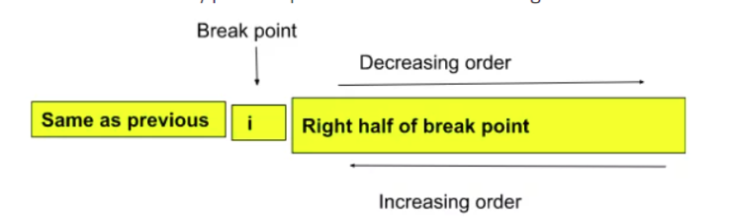

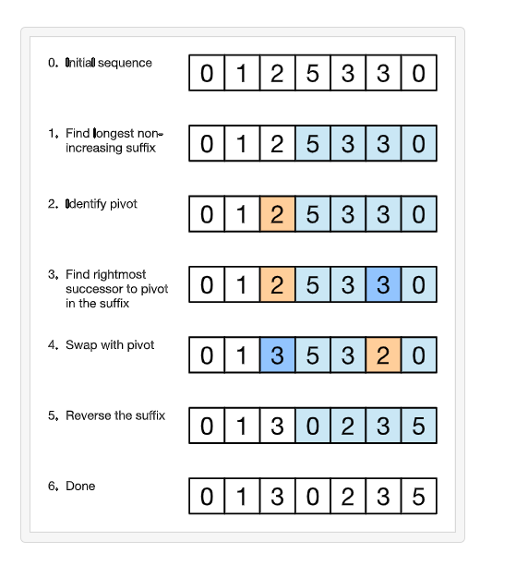

Maximum Subarray
https://leetcode.com/problems/maximum-subarray/description/
var maxSubArray = function(nums) {
let maxUntill=nums[0];
let max=nums[0]
for(let i=1;i<nums.length;i++){
maxUntill=Math.max(nums[i],nums[i]+maxUntill)
max=Math.max(max,maxUntill)
}
return max
};

let nums = [-2, 1, -3, 4, -1, 2, 1, -5, 4];

let result = maxSubArray(nums);

console.log(result); // Expected Output: 6

Sort Colors (Dutch flags)
https://leetcode.com/problems/sort-colors/description/
var sortColors = function(nums) {
let start = 0;
let mid = 0;
let end = nums.length - 1
while (mid <= end) {
if (nums[mid] == 0) {
[nums[mid], nums[start]] = [nums[start], nums[mid]]
start += 1
mid += 1
}
//must be else if
else if (nums[mid] == 2) {
[nums[mid], nums[end]] = [nums[end], nums[mid]]
end -= 1
} else {
mid += 1
}
}
};

// Test Case
let nums = [2, 0, 2, 1, 1, 0];

sortColors(nums);

console.log(nums); // Expected Output: [0, 0, 1, 1, 2, 2]

Second largest number in array
function getSecondLargest(arr) {
let firstLargest = -Infinity;
let secondLargest = Infinity;
for (let ele of arr) {
if (ele > firstLargest) {
secondLargest = firstLargest;
firstLargest = ele;
} else if (ele > secondLargest && ele != firstLargest) {
secondLargest = ele;
}
}
return secondLargest;
}
let arr = [12, 34, 34, 23, 232, -10, -38, 45, 230];
let res = getSecondLargest(arr);
console.log(res);

Sort 0 and 1’s

function sortZerosOnes(arr){

let left=0
let n=arr.length
for(let i=0;i<n;i++){
if(arr[i]==0){
[arr[i],arr[left]]=[arr[left],arr[i]];
left+=1
}
}
console.log(arr)
}
sortZerosOnes([0,1,1,0,0,1,1,0])

Spiral traversal matrix

/**
* @param {number[][]} matrix
* @return {number[]}
*/
var spiralOrder = function(matrix) {
let top=0;
let bottom=matrix.length-1;
let left=0;
let right=matrix[0].length-1;
let res=[]
while(top<=bottom && left<=right){
for(let i=left;i<=right;i++){
res.push(matrix[top][i])
}
top++;
for(let i=top;i<=bottom;i++){
res.push(matrix[i][right])
}
right--;
if(top<=bottom){
for(let i=right;i>=left;i--){
res.push(matrix[bottom][i])
}
bottom--
}
if(left<=right){
for(let i=bottom;i>=top;i--){
res.push(matrix[i][left])
}
left++
}
}
return res
};
top bottom => indicates row
left right =>indicate colo

let matrix1 = [
[1, 2, 3],
[4, 5, 6],
[7, 8, 9]
];

let result1 = spiralOrder(matrix1);

console.log(result1); // Expected Output: [1, 2, 3, 6, 9, 8, 7, 4, 5]

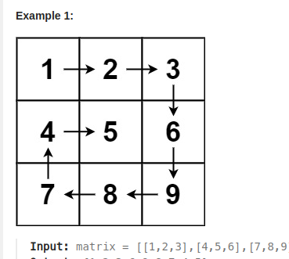

Best Time to Buy and Sell Stock
https://leetcode.com/problems/best-time-to-buy-and-sell-stock/description/
var maxProfit = function(prices) {
let minPrice=prices[0];
let maxi=0;
for(let i=0;i<prices.length;i++){
minPrice=Math.min(minPrice,prices[i]);
maxi=Math.max(maxi,prices[i]-minPrice)
}
return maxi
}

let prices1 = [1, 2, 3, 4, 5];

let result1 = maxProfit(prices1);

console.log(result1); // Expected Output: 4

Merge Intervals
https://leetcode.com/problems/merge-intervals/description/
var merge = function(intervals) {
intervals.sort((a, b) => a[0] - b[0])
let res = [intervals[0]]
let prev = intervals[0]
let start = 0;
let end = 1
for (let current of intervals.slice(1)) {
if (current[start] <= res.at(-1)[end]) {
res.at(-1)[end] = Math.max(current[end], res.at(-1)[end])
} else {
res.push(current)
}
}
return res
};
let intervals1 = [[1, 3], [2, 6], [8, 10], [15, 18]];
let result1 = merge(intervals1);
console.log(result1); // Expected Output: [[1, 6], [8, 10], [15, 18]]

Count Inversions
https://www.codingninjas.com/studio/problems/count-inversions_615?leftPanelTabValue=PROBLEM
from os import *
from sys import *
from collections import *
from math import *
count=0
def merge(arr,low,mid,high):
global count
temp=[]
left=low;
right=mid+1
while(left<=mid and right<=high):
if(arr[left]<=arr[right]):
temp.append(arr[left]);
left+=1;
else:
count+=mid-left+1
temp.append(arr[right]);
right+=1;
while(left<=mid):
temp.append(arr[left]);
left+=1;
while(right<=high):
temp.append(arr[right])
right+=1
for i in range(low,high+1):
arr[i]=temp[i-low]
# print(arr)
def mergeSort(arr,start,end):
if(start>=end):
return
mid=(start+end)//2
mergeSort(arr,start,mid)
mergeSort(arr,mid+1,end)
merge(arr,start,mid,end)
def getInversions(arr, n) :
# Write your code here.
global count
count=0
start=0;
end=n-1;
mergeSort(arr,start,end)
# print(arr)
return count
# Taking inpit using fast I/O.
def takeInput() :
n = int(input())
arr = list(map(int, stdin.readline().strip().split(" ")))
return arr, n
# Main.
arr, n = takeInput()
print(getInversions(arr, n))

Merge Sorted Array
https://leetcode.com/problems/merge-sorted-array/description/
/**
* @param {number[]} nums1
* @param {number} m
* @param {number[]} nums2
* @param {number} n
* @return {void} Do not return anything, modify nums1 in-place instead.
*/
var merge = function (nums1, m, nums2, n) {
// [1,2,3,0,0,0]
// [2,5,6]
let l = m + n - 1;
m -= 1;
n -= 1;
while (l >= 0) {
if (n < 0 || nums1[m] > nums2[n]) {
nums1[l] = nums1[m--];
} else {
nums1[l] = nums2[n--];
}
l -= 1;
}
};
let nums1 = [1, 2, 3, 0, 0, 0];
let m = 3;
let nums2 = [2, 5, 6];
let n = 3;
merge(nums1, m, nums2, n);
console.log(nums1); // Expected Output: [1, 2, 2, 3, 5, 6]

Find the Duplicate Number
https://leetcode.com/problems/find-the-duplicate-number/description/
/**
* @param {number[]} nums
* @return {number}
*/
var findDuplicate = function (a) {
// let sum=nums.reduce((a,b)=>a+b,0)
// let real_sum=((nums.length)*(nums.length-1))/2
// return Math.abs(real_sum-sum)
let table = {};
let n = a.length;
for (let i = 0; i < n; i++) {
if (a[i] in table) return a[i];
else table[a[i]] = "hi";
}
};
let nums1 = [1, 3, 4, 2, 2];
let result1 = findDuplicate(nums1);
console.log(result1); // Expected Output: 2

Rotate Image
https://leetcode.com/problems/rotate-image/description
var rotate = function(matrix) {
for (let i = 0; i < matrix.length; i++) {
for (let j = 0; j < matrix[0].length; j++) {
if (i > j)
[matrix[i][j], matrix[j][i]] = [matrix[j][i], matrix[i][j]]
}
}
for (let row = 0; row < matrix.length; row++) {
let colStart = 0;
let colEnd = matrix[0].length - 1
while (colStart < colEnd) {
[matrix[row][colStart], matrix[row][colEnd]] = [matrix[row][colEnd], matrix[row][colStart]]
colStart += 1;
colEnd -= 1
}
}
// console.log(matrix)
};
let matrix = [
[1, 2, 3],
[4, 5, 6],
[7, 8, 9]
];
rotate(matrix);
console.log(matrix);
[
[7, 4, 1],
[8, 5, 2],
[9, 6, 3]
]

Max Consecutive Ones
https://leetcode.com/problems/max-consecutive-ones/description/

/**
* @param {number[]} nums
* @return {number}
*/
var findMaxConsecutiveOnes = function(nums) {
let count=0
let max=0
for(let i=0;i<nums.length;i++){
if(nums[i]==1){
count+=1
}
else{
count=0
}
max=Math.max(max,count)
}
return max
};
// Test Case: Typical Case
let nums1 = [1, 1, 0, 1, 1, 1];
let result1 = findMaxConsecutiveOnes(nums1);
console.log(result1); // Expected Output: 3

Trapping Rain Water
https://leetcode.com/problems/trapping-rain-water/description/
/**
* @param {number[]} height
* @return {number}
*/
var trap = function (heights) {
let n = heights.length;
let rightMax = new Array(n).fill(0);
let leftMax1 = new Array(n).fill(0);
leftMax1[0] = heights[0];
for (let i = 1; i < n; i++) {
leftMax1[i] = Math.max(leftMax1[i - 1], heights[i]);
}
rightMax[n - 1] = heights[n - 1];
for (let i = n - 2; i >= 0; i--) {
rightMax[i] = Math.max(rightMax[i + 1], heights[i]);
}
let res = new Array(n);
let ans = 0;
for (let i = 0; i < n; i++) {
res[i] = Math.min(rightMax[i], leftMax1[i]) - heights[i];
ans += res[i];
}
return ans;
};
// Test Case: Simple Case
let heights1 = [0,1,0,2,1,0,1,3,2,1,2,1];
let result1 = trap(heights1);
console.log(result1); // Expected Output: 6

Valid Triangle Number
https://leetcode.com/problems/valid-triangle-number/description/
var triangleNumber = function (nums) {
nums.sort((a, b) => a - b);
let count = 0;
for (let i = nums.length - 1; i >= 2; i--) {
let left = 0;
let right = i - 1;
while (left < right) {
if (nums[left] + nums[right] > nums[i]) {
count = count + (right - left);
right--;
} else left++;
}
}
// console.log(count)
return count;
};

Mono stack

503. Next Greater Element II
https://leetcode.com/problems/next-greater-element-ii/description/

f
or next Greater element we are traversing from left to right,
so in stack it always conatins it privious elements.
arr[i] check if it greater than previous element in stack, if yes we just pop them out and
and for all those arr[i] is next greater element
var nextGreaterElements = function(nums) {
let originallen=nums.length
nums=[...nums,...nums]
let n=nums.length
let dp=new Array(n).fill(-1);
let stack=[]
for(let i=0;i<n;i++){
while(stack.length && nums[i]>nums[stack.at(-1)]){
let lastele = stack.pop()
dp[lastele]=nums[i]
}
stack.push(i)
}
return dp.slice(0,originallen)
};
let nums2 = [1, 2, 3, 4];
let result2 = nextGreaterElements(nums2);
console.log(result2); // Expected Output: [2, 3, 4, -1]

Daily Temperatures
https://leetcode.com/problems/daily-temperatures/description/
/**
* @param {number[]} temperatures
* @return {number[]}
*/
var dailyTemperatures = function (temperatures) {
let n = temperatures.length;
let res = new Array(n).fill(0);
stack = [];
for (let i = 0; i < n; i++) {
while (stack.length > 0 && temperatures[i] > temperatures[stack.at(-1)]) {
let lastele = stack.pop();
res[lastele] = i - lastele;
}
stack.push(i);
}
return res;
};
let temperatures1 = [73, 74, 75, 71, 69, 72, 76, 73];
let result1 = dailyTemperatures(temperatures1);
console.log(result1); // Expected Output: [1, 1, 4, 2, 1, 1, 0, 0]

Next Smallest
var nextSmallest = function(heights) {
let n=heights.length
let res=new Array(n).fill(-1)
let stack=[]
for(i=0;i<n;i++){
while(stack.length && heights[i]<heights[stack.at(-1)]){
let lastEle=stack.pop()
res[lastEle]=heights[i]
}
stack.push(i)
}
console.log(res)
};
input : [73,74,75,71,69,72,76,73]
ans=[
71, 71, 71, 69,
-1, -1, 73, -1
]

Largest Rectangle in Histogram
https://leetcode.com/problems/largest-rectangle-in-histogram/
/**
* @param {number[]} heights
* @return {number}
*/
var largestRectangleArea = function(heights) {
heights=[-1,...heights] //to make indexing from 1
let n=heights.length
let nextSm=new Array(n).fill(-1)
let prevSm=new Array(n).fill(-1)
let stack=[]
//next smallest
for(i=1;i<n;i++){
while(stack.length && heights[i]<heights[stack.at(-1)]){
let index=stack.pop()
nextSm[index]=i-1 // we have to take i-1 element as i is smallar than current i-1 need to pic
}
stack.push(i)
}
while(stack.length){
let index=stack.pop()
nextSm[index]=n-1
}
//previous smallest
stack=[]
for(i=n-1;i>0;i--){
while(stack.length && heights[i]<heights[stack.at(-1)]){
let index=stack.pop()
prevSm[index]=i+1 // i will be smaller than current so, need to pick i+1 as its size is atleast same as current
}
stack.push(i)
}
while(stack.length){
let index=stack.pop()
prevSm[index]=1
}
let maxArea=0
for(let i=1;i<n;i++){
let height=heights[i];
let width=nextSm[i]-prevSm[i]+1
console.log(height,width)
maxArea=Math.max(maxArea,height*width)
}
return maxArea
};
// Test Case: Typical Case
let heights = [2, 1, 5, 6, 2, 3];
let result = largestRectangleArea(heights);
console.log(result); // Expected Output: 10

Remove K Digits
https://leetcode.com/problems/remove-k-digits/
need to use monotonic increasing stack
/**
* @param {string} num
* @param {number} k
* @return {string}
*/
var removeKdigits = function (num, k) {
let stack = [];
let n = num.length;
for (let i = 0; i < n; i++) {
while (k > 0 && stack.length > 0 && num[i] < stack.at(-1)) {
stack.pop();
k--;
}
stack.push(num[i]);
}
while (k > 0) {
stack.pop();
k--;
}
let smalNum = stack.join("").replace(/^0+/, "");
if (smalNum == "") return "0";
return smalNum;
return stack.join("");
};
Input: num = "1432219", k = 3
Output: "1219"
need to removve 4 as threre is dip from 4 to 3
then remove 3 as dip form 3 to 2
then remove 2 as drop form 2 to 1
so finally 1219

Remove Duplicate Letters
https://leetcode.com/problems/remove-duplicate-letters/description/
/*var removeDuplicateLetters = function (s) {
const lastOccur = new Map();
const stack = [];
// Record the last occurrence of each character
for (let i = 0; i < s.length; i++) {
lastOccur.set(s[i], i);
}
for (let i = 0; i < s.length; i++) {
const char = s[i];
if (stack.includes(char)) continue;
while (
stack.length > 0 &&
char < stack.at(-1) &&
i < lastOccur.get(stack.at(-1))
// to check will occur later again, remove from stack
) {
stack.pop();
}
stack.push(char);
}
return stack.join("");
};*/
//bettter version
/**
* @param {string} s
* @return {string}
*/
var removeDuplicateLetters = function (s) {
let lastOccur = new Map();
let stack = [];
let n = s.length;
let set = new Set();
for (let i = 0; i < n; i++) {
lastOccur.set(s[i], i);
}
for (let i = 0; i < n; i++) {
let char = s[i];
if (set.has(char)) {
continue;
}
while (
stack.length > 0 &&
char < stack.at(-1) &&
i < lastOccur.get(stack.at(-1))
) {
let lastEle = stack.pop();
set.delete(lastEle);
}
stack.push(char);
set.add(char);
}
return stack.join("");
};
et's illustrate this with an example. Consider the string s = "cbacdcbc".
Populate lastOccur:
arduino
Copy code
lastOccur = { 'c': 7, 'b': 6, 'a': 2, 'd': 4 }

Map data structure based problems

Decode words
function decode(words, message) {
// Create a map to store the original words with their encoded keys
const wordMap = new Map();
// Helper function to generate a key by sorting the middle characters
function getKey(word) {
if (word.length <= 2) return word;
const middle = word.slice(1, -1).split('').sort().join('');
return word[0] + middle + word[word.length - 1];
}
// Populate the map with original words and their keys
for (const word of words) {
const key = getKey(word);
wordMap.set(key, word);
}
// Split the message into words and decode each one
const decodedWords = message.split(' ').map(scrambledWord => {
const key = getKey(scrambledWord);
return wordMap.get(key);
});
// Join the decoded words into a single string and return
return decodedWords.join(' ');
}
// Example usage
const words = ['orange', 'apple', 'banana', 'grape', 'pear'];
const message = 'ograen apelp bnaana gerpa paer';
console.log(decode(words, message)); // Output: "orange apple banana grape pear"

LRU cache

/**
* @param {number} capacity
*/
var LRUCache = function (capacity) {
this.cache = new Map();
this.size = capacity;
};
/**
* @param {number} key
* @return {number}
*/
LRUCache.prototype.get = function (key) {
if (!this.cache.has(key)) return -1;
let val = this.cache.get(key);
this.cache.delete(key);
this.cache.set(key, val);
return val;
};
/**
* @param {number} key
* @param {number} value
* @return {void}
*/
LRUCache.prototype.put = function (key, value) {
this.cache.delete(key);
this.cache.set(key, value);
// console.log(this.cache)
if (this.cache.size > this.size) {
const firstItem = this.cache.keys().next().value;
this.cache.delete(firstItem);
}
};
class LRUCache {
/**
* @param {number} capacity
*/
constructor(capacity) {
this.cache = new Map();
this.capacity = capacity;
}
/**
* @param {number} key
* @return {number}
*/
get(key) {
if (!this.cache.has(key)) return -1;
const value = this.cache.get(key);
this.cache.delete(key);
this.cache.set(key, value);
return value;
}
/**
* @param {number} key
* @param {number} value
* @return {void}
*/
put(key, value) {
if (this.cache.has(key)) {
this.cache.delete(key);
}
this.cache.set(key, value);
if (this.cache.size > this.capacity) {
const firstKey = this.cache.keys().next().value;
this.cache.delete(firstKey);
}
}
}
// Create a new LRUCache instance with a capacity of 2
const obj = new LRUCache(2);
// Perform operations on the cache
obj.put(1, 1); // Cache: {1: 1}
obj.put(2, 2); // Cache: {1: 1, 2: 2}
console.log(obj.get(1)); // Expected Output: 1, Cache: {2: 2, 1: 1} (1 is accessed and moved to the end)
obj.put(3, 3); // Cache: {1: 1, 3: 3} (2 is evicted due to capacity constraint)
console.log(obj.get(2)); // Expected Output: -1 (2 is not present in the cache)
obj.put(4, 4); // Cache: {3: 3, 4: 4} (1 is evicted due to capacity constraint)
console.log(obj.get(1)); // Expected Output: -1 (1 is not present in the cache)
console.log(obj.get(3)); // Expected Output: 3, Cache: {4: 4, 3: 3} (3 is accessed and moved to the end)
console.log(obj.get(4)); // Expected Output: 4, Cache: {3: 3, 4: 4} (4 is accessed and remains in the cache)

Two Sum
https://leetcode.com/problems/two-sum/submissions/1175610905/
var twoSum = function (nums, target) {
let map = new Map();
for (let i = 0; i < nums.length; i++) {
if (map.has(target - nums[i])) {
return [i, map.get(target - nums[i])];
} else {
map.set(nums[i], i);
}
}
return [];
};
// Test Case: Typical Case
let nums = [2, 7, 11, 15];
let target = 9;
let result = twoSum(nums, target);
console.log(result); // Expected Output: [1, 0] (indices of 7 and 2 which sum up to 9)

Longest Consecutive Sequence
https://leetcode.com/problems/longest-consecutive-sequence/
/**
* @param {number[]} nums
* @return {number}
*/
var longestConsecutive = function (nums) {
let table = new Set([...nums]);
let max = 0;
for (let num of nums) {
if (!table.has(num - 1)) {
let current = num;
let count = 0;
while (table.has(current)) {
current++;
count++;
max = Math.max(count, max);
}
}
}
return max;
};
// Test Case: Typical Case
let nums = [100, 4, 200, 1, 3, 2];
let result = longestConsecutive(nums);
console.log(result); // Expected Output: 4 (The longest consecutive sequence is [1, 2, 3, 4])

Largest subarray with 0 sum
https://www.geeksforgeeks.org/problems/largest-subarray-with-0-sum/1
class Solution {
maxLen(arr, n) {
//code here
let map = new Map();
let sum = 0;
let maxi = 0;
for (let i = 0; i < n; i++) {
sum = sum + arr[i];
if (sum == 0) {
maxi = i + 1;
} else if (map.has(sum)) {
console.log(i, map.get(sum));
maxi = Math.max(maxi, i - map.get(sum));
} else {
map.set(sum, i);
}
}
return maxi;
}
}
// Test Case: Typical Case
let arr = [15, -2, 2, -8, 1, 7, 10, 23];
let n = arr.length;
const solution = new Solution();
let result = solution.maxLen(arr, n);
console.log(result); // Expected Output: 5 (The subarray with sum 0 is [-2, 2, -8, 1, 7])

Longest Substring Without Repeating Characters
https://leetcode.com/problems/longest-substring-without-repeating-characters/description/
1st method
/**
* @param {string} s
* @return {number}
*/
var lengthOfLongestSubstring = function (s) {
let left = 0;
let table = new Set();
let maxi = 0;
for (let right = 0; right < s.length; right++) {
while (table.has(s[right])) {
table.delete(s[left]);
left += 1;
}
table.add(s[right]);
maxi = Math.max(maxi, right - left + 1);
}
return maxi;
};
/**
* @param {string} s
* @return {number}
*/
var lengthOfLongestSubstring = function (s) {
let maxi = 0;
let table = new Map();
let left = 0;
for (let i = 0; i < s.length; i++) {
if (table.has(s[i])) {
left = Math.max(left, table.get(s[i]) + 1);
}
table.set(s[i], i);
maxi = Math.max(maxi, i - left + 1);
}
return maxi;
};
Input: "abcabcbb"
Expected Output: 3
Test Case 3:
Input: "pwwkew"
Expected Output: 3

Roman to Integer and Intget to Roam
https://leetcode.com/problems/roman-to-integer/description/
/**
* @param {string} s
* @return {number}
*/
var romanToInt = function(s) {
let hash=new Map([["I",1],["V",5],["X",10],["L",50],["C",100],["D",500],["M",1000]])
let res=0
for(let i=0;i<s.length;i++){
if(i+1<s.length && hash.get(s[i])<hash.get(s[i+1])){
res=res-hash.get(s[i])
}
else{
res=res+hash.get(s[i])
}
console.log(res)
}
return res;
};
var romanToInt = function(s) {
// Define an object to store the numerical values of each Roman numeral
let numeralValues = {
"I": 1,
"V": 5,
"X": 10,
"L": 50,
"C": 100,
"D": 500,
"M": 1000
};
let res = 0; // Initialize the result variable to store the integer value
// Loop through each character in the Roman numeral string
for (let i = 0; i < s.length; i++) {
// Check if the current numeral is smaller than the next one
if (i + 1 < s.length && numeralValues[s[i]] < numeralValues[s[i + 1]]) {
// If it is, subtract its value from the result
res = res - numeralValues[s[i]];
} else {
// If not, add its value to the result
res = res + numeralValues[s[i]];
}
console.log(res); // Log the current result value during each iteration
}
return res; // Return the final result
};
romanToInt("MMXXIV"); // Call the function with the Roman numeral "MMXXIV"
The main logic of the code lies in iterating through the Roman numeral string and determining whether to add or subtract the value of each numeral based on its position relative to the next numeral.
Here's how it works:
1. It loops through each character in the Roman numeral string.
2. For each character:
- If the current numeral is smaller than the next numeral, it subtracts its value from the result.
- If the current numeral is not smaller than the next numeral, it adds its value to the result.
This logic ensures that it correctly handles cases where a smaller numeral appears before a larger one, indicating subtraction, and cases where no subtraction is needed.

Integer to Roman
https://leetcode.com/problems/integer-to-roman/description/
var intToRoman = function (num) {
let map = {
M: 1000,
CM: 900,
D: 500,
CD: 400,
C: 100,
XC: 90,
L: 50,
XL: 40,
X: 10,
IX: 9,
V: 5,
IV: 4,
I: 1,
};
// total 13 mappings
let res = "";
for (let key in map) {
while (num >= map[key]) {
res = res + key;
num = num - map[key];
}
}
return res;
};

console.log(intToRoman(9)); // Expected: "IX"
console.log(intToRoman(58)); // Expected: "LVIII"
console.log(intToRoman(1994)); // Expected: "MCMXCIV"

Recurrsion

Letter Combinations of a Phone Number
https://leetcode.com/problems/letter-combinations-of-a-phone-number/description/?envType=list&envId=xlere2g3

/**
* @param {string} digits
* @return {string[]}
*/
var letterCombinations = function (digits) {
if (digits == null || digits.length === 0) return [];
let map = new Map();
map.set("2", "abc");
map.set("3", "def");
map.set("4", "ghi");
map.set("5", "jkl");
map.set("6", "mno");
map.set("7", "pqrs");
map.set("8", "tuv");
map.set("9", "wxyz");
let res = [];
let helper = (index, currSt) => {
if (currSt.length == digits.length) {
res.push(currSt);
return;
}
for (let c of map.get(digits[index])) {
helper(index + 1, currSt + c);
}
};
helper(0, "");
return res;
};
//another way
/**
* @param {string} digits
* @return {string[]}
*/
var letterCombinations = function (digits) {
if (!digits) return [];
let res = [];
let temp = [];
let map = {};
map[2] = "abc";
map[3] = "def";
map[4] = "ghi";
map[5] = "jkl";
map[6] = "mno";
map[7] = "pqrs";
map[8] = "tuv";
map[9] = "wxyz";
function helper(index) {
if (temp.length == digits.length) {
res.push(temp.join(""));
return;
}
for (let ch of map[digits[index]]) {
temp.push(ch);
helper(index + 1);
temp.pop();
}
}
helper(0);
return res;
};
"abc" "def"
//Certainly! Let's represent the function calls and their respective arguments in a tree-like structure:
letterCombinations("23")
|
└── go(0, '')
├── go(1, 'a')
| ├── go(2, 'ad') => "ad"
| ├── go(2, 'ae') => "ae"
| └── go(2, 'af') => "af"
|
├── go(1, 'b')
| ├── go(2, 'bd') => "bd"
| ├── go(2, 'be') => "be"
| └── go(2, 'bf') => "bf"
|
└── go(1, 'c')
├── go(2, 'cd') => "cd"
├── go(2, 'ce') => "ce"
└── go(2, 'cf') => "cf"
letterCombinations("234")
|
└── helper(0, '')
├── helper(1, 'a')
| ├── helper(2, 'ad')
| | ├── helper(3, 'adg') => "adg"
| | ├── helper(3, 'adh') => "adh"
| | └── helper(3, 'adi') => "adi"
| |
| ├── helper(2, 'ae')
| | ├── helper(3, 'aeg') => "aeg"
| | ├── helper(3, 'aeh') => "aeh"
| | └── helper(3, 'aei') => "aei"
| |
| └── helper(2, 'af')
| ├── helper(3, 'afg') => "afg"
| ├── helper(3, 'afh') => "afh"
| └── helper(3, 'afi') => "afi"
|
├── helper(1, 'b')
| ├── helper(2, 'bd')
| | ├── helper(3, 'bdg') => "bdg"
| | ├── helper(3, 'bdh') => "bdh"
| | └── helper(3, 'bdi') => "bdi"
| |
| ├── helper(2, 'be')
| | ├── helper(3, 'beg') => "beg"
| | ├── helper(3, 'beh') => "beh"
| | └── helper(3, 'bei') => "bei"
| |
| └── helper(2, 'bf')
| ├── helper(3, 'bfg') => "bfg"
| ├── helper(3, 'bfh') => "bfh"
| └── helper(3, 'bfi') => "bfi"
|
└── helper(1, 'c')
├── helper(2, 'cd')
| ├── helper(3, 'cdg') => "cdg"
| ├── helper(3, 'cdh') => "cdh"
| └── helper(3, 'cdi') => "cdi"
|
├── helper(2, 'ce')
| ├── helper(3, 'ceg') => "ceg"
| ├── helper(3, 'ceh') => "ceh"
| └── helper(3, 'cei') => "cei"
|
└── helper(2, 'cf')
├── helper(3, 'cfg') => "cfg"
├── helper(3, 'cfh') => "cfh"
└── helper(3, 'cfi') => "cfi"

Combinations
https://leetcode.com/problems/combinations/description/?envType=list&envId=xlere2g3
/**
* @param {number} n
* @param {number} k
* @return {number[][]}
*/
var combine = function (n, k) {
let arr = new Array(n).fill(0).map((item, index) => index + 1);
//console.log(arr);
let res = [];
let ds = [];
helper(0);
return res;
function helper(index) {
if (ds.length == k) {
// console.log("base",ds)
res.push([...ds]);
return;
}
if (index == n) return;
// console.log([...ds],index,'inside')
ds.push(arr[index]);
helper(index + 1);
ds.pop();
// console.log([...ds],index,'inside2')
helper(index + 1);
}
};
// Test Case: Typical Case
let n1 = 4, k1 = 2;
let result1 = combine(n1, k1);
console.log(result1);
// Expected Output: [
// [1, 2],
// [1, 3],
// [1, 4],
// [2, 3],
// [2, 4],
// [3, 4]
// ]

Subset Sums
https://www.geeksforgeeks.org/problems/subset-sums2234/1
class Solution {
subsetSums(arr, n) {
//code here
let result = [];
this.helper( n - 1, 0);
return result.sort((a, b) => a - b);
}
helper( index, sum) {
// console.log(index)
if (index < 0) {
// console.log(result)
result.push(sum);
return;
}
this.helper(index - 1, sum + arr[index);
this.helper( index - 1, sum);
}
}
let arr1 = [1, 2, 3];
let n1 = arr1.length;
const solution1 = new Solution();
let result1 = solution1.subsetSums(arr1, n1);
console.log(result1);
// Expected Output: [0, 1, 2, 3, 3, 4, 5, 6]

Subsets
https://leetcode.com/problems/subsets/description/?envType=list&envId=xlere2g3
/**
* @param {number[]} nums
* @return {number[][]}
*/
var subsets = function (nums) {
let res = [];
let ds = [];
let n = nums.length;
var combination = (index, ds, k) => {
if (ds.length == k) {
// console.log(ds,'in if')
res.push([...ds]);
return;
}
if (index < 0) return;
// console.log(index,ds)
ds.push(nums[index]);
combination(index - 1, ds, k);
ds.pop();
combination(index - 1, ds, k);
};
// it is just extension of combination of size k wheren k is from 0 ton n
for (let i = 0; i <= n; i++) {
combination(n - 1, ds, i);
}
return res;
};
// altrenate solution
/**
* @param {number[]} nums
* @return {number[][]}
*/
var subsets = function (nums) {
let res = [];
let ds = [];
let n = nums.length;
var combination = (index) => {
if (index < 0) {
res.push([...ds]);
return;
}
ds.push(nums[index]);
combination(index - 1);
ds.pop();
combination(index - 1);
};
combination(n - 1);
return res;
};
// Test Case: Typical Case
let nums1 = [1, 2, 3];
let result1 = subsets(nums1);
console.log(result1);
// Expected Output: [
// [],
// [1],
// [2],
// [1, 2],
// [3],
// [1, 3],
// [2, 3],
// [1, 2, 3]
// ]

Subsets II
https://leetcode.com/problems/subsets-ii/
/**
* @param {number[]} nums
* @return {number[][]}
*/
var subsetsWithDup = function (nums) {
nums.sort((a, b) => a - b);
let res = [];
let n = nums.length;
let ds = [];
helper(n - 1);
return res;
function helper(index) {
// console.log(index)
if (index < 0) {
res.push([...ds]);
return;
}
ds.push(nums[index]);
helper(index - 1);
ds.pop();
while (index > 0 && nums[index] == nums[index - 1]) index--;
helper(index - 1);
}
};
let nums1 = [1, 2, 2];
let result1 = subsetsWithDup(nums1);
console.log(result1);
// Expected Output: [
// [],
// [1],
// [1, 2],
// [1, 2, 2],
// [2],
// [2, 2]
// ]

Combination Sum
https://leetcode.com/problems/combination-sum/
/**
* @param {number[]} candidates
* @param {number} target
* @return {number[][]}
*/
var combinationSum = function (candidates, target) {
let res = [];
let ds = [];
let n = candidates.length;
helper(n - 1, target, ds);
// console.log(res)
return res;
function helper(index, target, ds) {
if (target == 0) {
res.push([...ds]);
return;
}
if (target < 0) return;
if (index < 0) return;
// console.log(ds,target)
ds.push(candidates[index]);
//here we are sending index because we can use same number any number of times
helper(index, target - candidates[index], ds);
ds.pop();
helper(index - 1, target, ds);
}
};
let candidates1 = [2, 3, 6, 7];
let target1 = 7;
let result1 = combinationSum(candidates1, target1);
console.log(result1);
// Expected Output: [
// [2, 2, 3],
// [7]
// ]

Combination Sum II
https://leetcode.com/problems/combination-sum-ii/description/
/**
* @param {number[]} candidates
* @param {number} target
* @return {number[][]}
*/
var combinationSum2 = function (candidates, target) {
let arr = candidates;
arr.sort((a, b) => a - b);
let res = [];
let ds = [];
let n = arr.length;
helper(n - 1, target);
return res;
function helper(index, target) {
//below condition has to on top
//because may be for index<0 also gives answer
if (target == 0) {
res.push([...ds]);
return;
}
if (target < 0) return;
if (index < 0) return;
ds.push(arr[index]);
helper(index - 1, target - arr[index]); //pick
ds.pop();
while (index > 0 && arr[index] == arr[index - 1]) index--;
helper(index - 1, target); //not pick
}
};

let candidates1 = [10, 1, 2, 7, 6, 1, 5];
let target1 = 8;
let result1 = combinationSum2(candidates1, target1);
console.log(result1);
// Expected Output: [
// [1, 1, 6],
// [1, 2, 5],
// [1, 7],
// [2, 6]
// ]

Palindrome Partitioning
https://leetcode.com/problems/palindrome-partitioning/
/**
* @param {string} s
* @return {string[][]}
*/
var partition = function (s) {
let result = [];
let ds = [];
helper(0);
return result;
function helper(start) {
if (start === s.length) {
result.push([...ds]);
return;
}
for (let end = start; end < s.length; end++) {
let subStr = s.slice(start, end + 1);
if (isPalin(subStr)) {
ds.push(subStr);
helper(end + 1); // its end + i (variable inside loop)
ds.pop();
}
}
}
function isPalin(s) {
let reverse = s.split("").reverse().join("");
return s === reverse;
}
};
let s1 = "aab";
let result1 = partition(s1);
console.log(result1);
// Expected Output:
// [
// ["a", "a", "b"],
// ["aa", "b"]
// ]

Permutations
https://leetcode.com/problems/permutations/

//solution 2
/**
* @param {number[]} nums
* @return {number[][]}
*/
var permute = function(nums) {
nums.sort((a, b) => a - b);
let res = [];
let ds = [];
let n=nums.length
let used=new Array(nums.length).fill(false)
let helper = (index) => {
if (index<0) {
res.push([...ds]);
return;
}
for (let i = 0; i < nums.length; i++) {
if (used[i] ) {
continue;
// Skip if the number is already used or if it's a duplicate and the previous one is not used
}
ds.push(nums[i]);
used[i] = true;
helper(index - 1);
ds.pop();
used[i] = false;
}
};
helper(n-1 );
return res;
}
let nums1 = [1, 2, 3];
let result1 = permute(nums1);
console.log(result1);
// Expected Output:
// [
// [1, 2, 3],
// [1, 3, 2],
// [2, 1, 3],
// [2, 3, 1],
// [3, 1, 2],
// [3, 2, 1]
// ]

Permutations II
https://leetcode.com/problems/permutations-ii/?envType=list&envId=xlere2g3

/**
* @param {number[]} nums
* @return {number[][]}
*/
var permuteUnique = function (nums) {
nums.sort((a, b) => a - b);
let res = [];
let ds = [];
let n = nums.length;
let used = new Array(nums.length).fill(false);
let helper = (index) => {
if (index < 0) {
res.push([...ds]);
return;
}
for (let i = 0; i < nums.length; i++) {
if (used[i] || (i > 0 && nums[i] === nums[i - 1] && !used[i - 1])) {
continue; // Skip if the number is already used or if it's a duplicate and the previous one is not used
}
ds.push(nums[i]);
used[i] = true;
helper(index - 1);
ds.pop();
used[i] = false;
}
};
helper(n - 1);
return res;
};
let nums1 = [1, 2, 3];
let result1 = permuteUnique(nums1);
console.log(result1);
// Expected Output:
// [
// [1, 2, 3],
// [1, 3, 2],
// [2, 1, 3],
// [2, 3, 1],
// [3, 1, 2],
// [3, 2, 1]
// ]

N-Queens
https://leetcode.com/problems/n-queens/

Rat in a Maze Problem - I
https://www.geeksforgeeks.org/problems/rat-in-a-maze-problem/1
class Solution {
findPath(m, n) {
//code here
let visited = new Array(n).fill(0).map(() => new Array(n).fill(false));
let path = [];
let result = [];
this.helper(m, 0, 0, path, visited, n, result);
return result.sort();
}
helper(grid, row, col, path, visited, n, result) {
if (row == n - 1 && col == n - 1) {
result.push(path.slice().join("")); // Push a copy of the path array
// console.log(path)
return;
}
visited[row][col] = true;
let rowMove = [-1, 1, 0, 0];
let colMove = [0, 0, -1, 1];
let dir = ["U", "D", "L", "R"];
for (let i = 0; i < rowMove.length; i++) {
let nextRow = row + rowMove[i];
let nexCol = col + colMove[i];
let newPath = [...path, dir[i]];
if (this.isSafe(nextRow, nexCol, grid, visited, n)) {
this.helper(grid, nextRow, nexCol, newPath, visited, n, result);
}
}
visited[row][col] = false;
}
isSafe(row, col, grid, visited, n) {
return (
row >= 0 &&
row < n &&
col >= 0 &&
col < n &&
visited[row][col] == false &&
grid[row][col] == 1
);
}
}
let grid1 = [
[1, 0, 0],
[1, 1, 0],
[0, 1, 1]
];
let solution1 = new Solution();
let result1 = solution1.findPath(grid1, 3);
console.log(result1);
// Expected Output:
// ["DDR", "DDRR", "DRDD", "RDD", "RRDD"]
// These are the valid paths from (0,0) to (2,2) in the grid.

Binary Search

Single Element in a Sorted Array
https://leetcode.com/problems/single-element-in-a-sorted-array/description/
/**
* @param {number[]} nums
* @return {number}
*/
var singleNonDuplicate = function (nums) {
let start = 0;
let end = nums.length - 1;
if (end == 0) return nums[0];
if (nums[start] != nums[start + 1]) return nums[start];
if (nums[end] != nums[end - 1]) return nums[end];
while (start <= end) {
let mid = Math.floor((start + end) / 2);
// console.log(mid)
if (nums[mid] != nums[mid + 1] && nums[mid] != nums[mid - 1])
return nums[mid];
if (
(mid % 2 == 0 && nums[mid] == nums[mid + 1]) ||
(mid % 2 == 1 && nums[mid] == nums[mid - 1])
)
start = mid + 1;
else end = mid - 1;
}
return -1;
};
[1,1,2,2,3,3,4,4,6,6]
if two elements are present then even index and even index+1 should be same
so we have to serch from mid+1 to end
else
we have to search in left side 0. left
let nums1 = [1, 1, 2, 2, 3, 3, 4, 4, 6, 6];
let result1 = singleNonDuplicate(nums1);
console.log(result1);

Search in Rotated Sorted Array
https://leetcode.com/problems/search-in-rotated-sorted-array/
var search = function (nums, target) {
let low = 0;
let high = nums.length - 1;
let arr = nums;
while (low <= high) {
let mid = Math.floor((low + high) / 2);
if (target == arr[mid]) return mid;
if (arr[low] <= arr[mid]) {
if (target >= arr[low] && target <= arr[mid]) {
high = mid - 1;
} else {
low = mid + 1;
}
} else {
if (target >= arr[mid] && target <= arr[high]) {
low = mid + 1;
} else {
high = mid - 1;
}
}
}
return -1;
};
let nums1 = [4, 5, 6, 7, 0, 1, 2];
let target1 = 0;
let result1 = search(nums1, target1);
console.log(result1);
// Expected Output: 4
// The target 0 is found at index 4 in the array [4, 5, 6, 7, 0, 1, 2].

Median of Two Sorted Arrays
https://leetcode.com/problems/median-of-two-sorted-arrays/description/
var findMedianSortedArrays = function (nums1, nums2) {
// num1 should be small
if (nums1.length > nums2.length) {
let temp = nums1;
nums1 = nums2;
nums2 = temp;
}
let m = nums1.length;
let n = nums2.length;
let low = 0;
let high = m;
while (low <= high) {
let cut1 = (low + high) >> 1;
let cut2 = Math.floor((m + n + 1) / 2) - cut1;
let l1 = cut1 == 0 ? -Infinity : nums1[cut1 - 1];
let l2 = cut2 == 0 ? -Infinity : nums2[cut2 - 1];
let r1 = cut1 == m ? Infinity : nums1[cut1];
let r2 = cut2 == n ? Infinity : nums2[cut2];
if (l1 <= r2 && l2 <= r1) {
console.log(l1, l2, r1, r2);
if ((m + n) % 2 == 1) {
return Math.max(l1, l2);
} else {
return (Math.max(l1, l2) + Math.min(r1, r2)) / 2;
}
} else if (l1 > r2) {
high = cut1 - 1;
} else {
low = cut1 + 1;
}
}
return 0.0;
};
let nums1 = [1, 3];
let nums2 = [2];
let result1 = findMedianSortedArrays(nums1, nums2);
console.log(result1);
// Expected Output: 2.0
// Median of [1, 2, 3] is 2.0.

K-th element of two Arrays
https://www.geeksforgeeks.org/problems/k-th-element-of-two-sorted-array1317/1
class Solution {
kthElement(A, B, n, m, k) {
//code here
if (A.length > B.length) {
let temp = A;
A = B;
B = temp;
n = A.length;
m = B.length;
}
// if A has 6 element and B has 5 element and k is 7 we have to pick atlease 7{k) -5(m) => 2 from A . because B has only 5 element
let low = Math.max(0, k - m);
// if A has 6 elemetn and k=2 then we have to pick max 2 from A . So we have to pick min of k,n
let high = Math.min(k, n);
while (low <= high) {
let cut1 = Math.floor((low + high) / 2);
let cut2 = k - cut1; // we have divide in such a way that k element in one group, remainng in other group
let l1 = cut1 == 0 ? -Infinity : A[cut1 - 1];
let l2 = cut2 == 0 ? -Infinity : B[cut2 - 1];
let r1 = cut1 == n ? Infinity : A[cut1];
let r2 = cut2 == m ? Infinity : B[cut2];
if (l1 <= r2 && l2 <= r1) {
return Math.max(l1, l2);
} else if (l1 > r2) {
high = cut1 - 1;
} else {
low = cut1 + 1;
}
}
return 1;
}
}
let solution = new Solution();
let A1 = [1, 3, 5, 7, 9];
let B1 = [2, 4, 6, 8];
let n1 = A1.length;
let m1 = B1.length;
let k1 = 5;
let result1 = solution.kthElement(A1, B1, n1, m1, k1);
console.log(result1);
// Expected Output: 5
// The 5th smallest element in [1, 2, 3, 4, 5, 6, 7, 8, 9] is 5.

areSquaresSumExist
function areSquaresSumExist(c) {
if (c < 0) return false; // Negative numbers cannot be expressed as sum of two squares
let start = 0;
let end = Math.floor(Math.sqrt(c));
while (start <= end) {
let sum = start * start + end * end;
if (sum === c) {
return true;
} else if (sum < c) {
start++;
} else {
end--;
}
}
return false;
}
// Example usage:
console.log(areSquaresSumExist(5)); // Output: true (2^2 + 1^2 = 5)
console.log(areSquaresSumExist(13)); // Output: true (3^2 + 2^2 = 13)
console.log(areSquaresSumExist(25)); // Output: true (5^2 + 0^2 = 25)
console.log(areSquaresSumExist(7)); // Output: false

Find Smallest Letter Greater Than Target
https://leetcode.com/problems/find-smallest-letter-greater-than-target/
var nextGreatestLetter = function(letters, target) {
let low = 0;
let high = letters.length - 1;
let ans = ""
while (low <= high) {
let mid = Math.floor((low + high) / 2)
if (letters[mid] > target) {
ans = letters[mid]
high = mid - 1
} else {
low = mid + 1
}
}
return ans == "" ? letters[0] : ans
};
Input: letters = ['a', 'c', 'f', 'h'], target = 'd'
Output: 'f'
Explanation: The smallest letter greater than 'd' is 'f'.

Find Peak Element
https://leetcode.com/problems/find-peak-element/description/
/**
* @param {number[]} nums
* @return {number}
*/
var findPeakElement = function (nums) {
let low = 0;
let high = nums.length - 1;
while (low <= high) {
let mid = Math.floor((low + high) / 2);
//ex: [3,5,7][mid mid+7] here 3 <5 so 3 cann't be peak element, so low=3
if (nums[mid] < nums[mid + 1]) {
low = mid + 1;
} else {
high = mid - 1;
}
}
return low; //need to return low
};

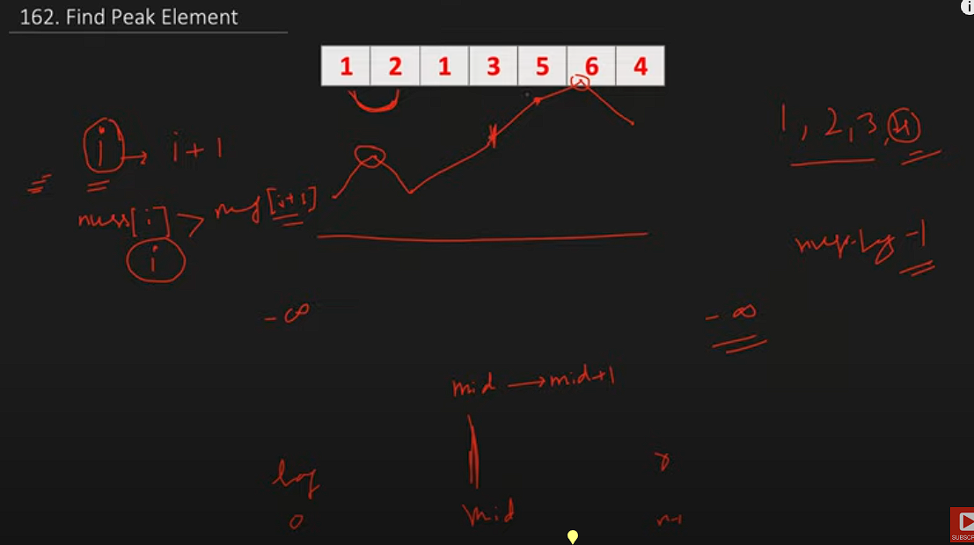

Peak Index in a Mountain Array
https://leetcode.com/problems/peak-index-in-a-mountain-array/?envType=list&envId=xleplgq3
/**
* @param {number[]} arr
* @return {number}
*/
var peakIndexInMountainArray = function (arr) {
let start = 0;
let end = arr.length - 1;
while (start <= end) {
let mid = Math.floor((start + end) / 2);
if (arr[mid] > arr[mid - 1] && arr[mid] > arr[mid + 1]) return mid;
// if mid is in increasing side , we just need to skil ex: [1,2,3,4,5,4,3,1] and
// mid is 3 mid+1 is 4 then skip left element
if (arr[mid] < arr[mid + 1]) {
start = mid + 1;
} else {
end = mid - 1;
}
}
};

console.log(peakIndexInMountainArray([1, 3, 5, 4, 2]));
// Expected: 2

Search in Rotated Sorted Array
https://leetcode.com/problems/find-minimum-in-rotated-sorted-array/description/?envType=list&envId=xleplgq3
/**
* @param {number[]} nums
* @param {number} target
* @return {number}
*/
var search = function(nums, target) {
let low=0;
let high=nums.length-1
let arr=nums
while(low<=high){
let mid=Math.floor((low+high)/2)
if(target==arr[mid]) return mid
if(arr[low]<=arr[mid]){
if(target>=arr[low] && target<=arr[mid]){
high=mid-1
}
else{
low=mid+1
}
}
else{
if(target>=arr[mid] && target<=arr[high]){
low=mid+1
}
else{
high=mid-1
}
}
}
return -1
};
console.log(search([4, 5, 6, 7, 0, 1, 2], 0)); // Expected output: 4
console.log(search([4, 5, 6, 7, 0, 1, 2], 3)); // Expected output: -1

Find Minimum in Rotated Sorted Array
https://leetcode.com/problems/find-smallest-letter-greater-than-target/description/
/**
* @param {number[]} nums
* @return {number}
*/
<https://www.youtube.com/watch?v=nhEMDKMB44g&t=789s>
var findMin = function(nums) {
let left=0; right=nums.length-1
let res=Number.MAX_SAFE_INTEGER
while(left<=right){
let mid=Math.floor((left+ right)/2)
console.log(nums[mid],'mid',left,right)
// pick min in sorted and elementate that portion as we alread picked smalles in sorted.
if(nums[left]<=nums[mid]){
res=Math.min(nums[left],res)
left=mid+1
}
else{
res=Math.min(nums[mid],res)
right=mid-1
}
}
return res;
};
console.log(findMin([3, 4, 5, 1, 2])); // Expected output: 1
console.log(findMin([4, 5, 6, 7, 0, 1, 2])); // Expected output: 0
console.log(findMin([11, 13, 15, 17])); // Expected output: 11

Search a 2D Matrix
https://leetcode.com/problems/search-a-2d-matrix/?envType=list&envId=xleplgq3
var searchMatrix = function(matrix, target) {
let right = matrix[0].length - 1;
let top = 0;
let n = matrix.length;
while (top < n && right >= 0) {
if (matrix[top][right] === target) {
return true; // Return true if target is found
} else if (matrix[top][right] < target) {
top++; // Move downwards if current element is less than target
} else {
right--; // Move leftwards if current element is greater than target
}
}
return false; // Return false if target is not found
};
var searchMatrix = function(matrix, target) {
let right=matrix[0].length-1
let top=0
let n=matrix.length
why top right posiitio? , because from top right array continuously decrease backwards,
increases donwwards
so if taget < current we need to back backwards
while(top<n && right>=0){
if(matrix[top][right]==target)
return 1
if(target<matrix[top][right]){
right-=1
}
else{
top+=1
}
}
return false
};

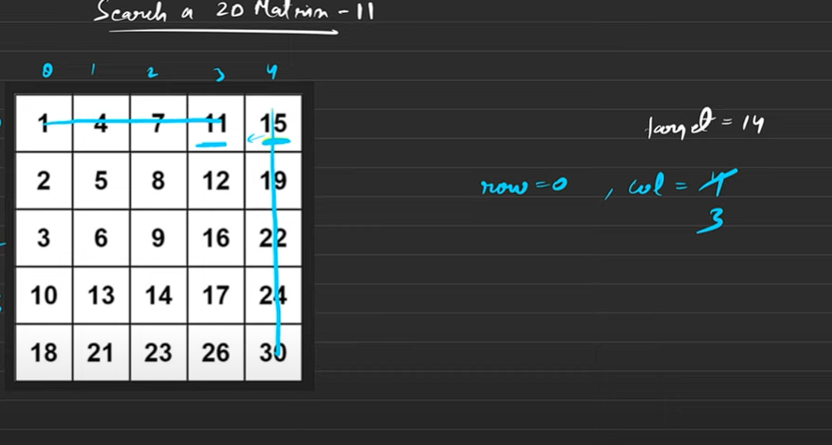

Heap based problems (solution in python)
from heqpq import *
bydefault it is minheap, but if we want max haap multipy no with -1
heappush(arr,num) => time complexity O(logn)
heappop(arr) =>return min element in array in O(log n) time
heappushpop(arr,num)
heapify(arr) => heapify arr in O(n)

Kth Largest Element in an Array
https://leetcode.com/problems/kth-largest-element-in-an-array/description/
import heapq
class Solution:
def findKthLargest(self, nums: List[int], k: int) -> int:
for i in range(len(nums)):
nums[i]=-nums[i]
heapq.heapify(nums)
while k>1:
heapq.heappop(nums)
k-=1
return -heapq.heappop(nums)
The time complexity of finding the kth largest element in an array using a heap in Python is O(n + k log n), where n is the number of elements in the array.
solution = Solution()
nums1 = [3, 2, 1, 5, 6, 4]
k1 = 2
result1 = solution.findKthLargest(nums1, k1)
print(result1)
# Expected Output: 5
# Explanation: The 2nd largest element in [3, 2, 1, 5, 6, 4] is 5.

Median finder

from heapq import *
class MedianFinder:
def __init__(self):
self.lo = []
self.hi = []
# lo => lowers, hi=>higher
def addNum(self, num):
# heappush(self.lo, -num) # lo is maxheap, so -1 * num
# heappush(self.hi, -self.lo[0]) # hi is minheap
# heappop(self.lo)
heappush(self.hi, -heappushpop(self.lo, -num))
if len(self.lo) < len(self.hi):
heappush(self.lo, -self.hi[0])
heappop(self.hi)
def findMedian(self):
if len(self.lo) > len(self.hi):
return -self.lo[0]
else:
return (self.hi[0] - self.lo[0]) / 2 # - as low has -ve values
# Your MedianFinder object will be instantiated and called as such:
# obj = MedianFinder()
# obj.addNum(num)
# param_2 = obj.findMedian()

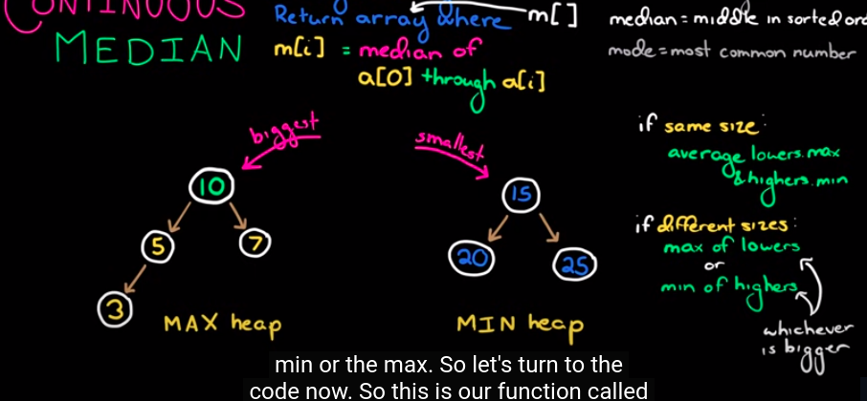

Sliding Window Maximum
https://leetcode.com/problems/sliding-window-maximum/description/

from heapq import *
class Solution:
def maxSlidingWindow(self, nums: List[int], k: int) -> List[int]:
result=[]
heapArr=[]
for i in range(k):
heappush(heapArr, (-nums[i],i))
result.append(-heapArr[0][0])
# till now we have [0,1,2]
for i in range(k,len(nums)):
#we are adding 4th here so
# 4-3=1 . so untill first index we have to remove. so index [2,3,4]. that way we have to remove <=i-k
heappush(heapArr, (-nums[i],i))
while(heapArr[0][1]<=i-k):
heappop(heapArr)
result.append(-heapArr[0][0])
return result
# we have to create head of size k, we should always maintain same k size.
# whatever indexs out of window, we need to reomve
nums = [1, 3, -1, -3, 5, 3, 6, 7]
k = 3
# Expected output: [3, 3, 5, 5, 6, 7]
# Explanation:
# Sliding window positions:
# [1, 3, -1], -3, 5, 3, 6, 7 => max = 3
# 1, [3, -1, -3], 5, 3, 6, 7 => max = 3
# 1, 3, [-1, -3, 5], 3, 6, 7 => max = 5
# 1, 3, -1, [-3, 5, 3], 6, 7 => max = 5
# 1, 3, -1, -3, [5, 3, 6], 7 => max = 6
# 1, 3, -1, -3, 5, [3, 6, 7] => max = 7
# Run the function and print the result
sol = Solution()
output = sol.maxSlidingWindow(nums, k)
print(output) # This will print: [3, 3, 5, 5, 6, 7]

Stack and Queue

Top K Frequent Elements
https://leetcode.com/problems/top-k-frequent-elements/
/**
* @param {number[]} nums
* @param {number} k
* @return {number[]}
*/
var topKFrequent = function (nums, k) {
let count = new Map();
let n = nums.length;
for (let i = 0; i < n; i++) {
count.set(nums[i], (count.get(nums[i]) ?? 0) + 1);
}
// console.log(count)
let freq = new Array(n + 1).fill(0).map(() => []);
// console.log(freq)
for ([key, count] of count.entries()) {
freq[count].push(key);
}
// console.log(freq)
// let kcount=0
let result = [];
for (let i = freq.length - 1; i >= 0; i--) {
for (n of freq[i]) {
result.push(n);
}
if (result.length == k) {
return result;
}
}
// console.log(result)
// return result
};

Valid Parentheses
https://leetcode.com/problems/valid-parentheses/

var isValid = function (s) {
let stack = [];
let store = new Map();
store.set("}", "{");
store.set(")", "(");
store.set("]", "[");
for (let char of s) {
if (store.has(char)) {
if(stack.length>0 && stack.at(-1)==store.get(char))
stack.pop()
else
return false
} else {
stack.push(char);
}
}
if (stack.length == 0) return true;
else return false;
};
console.log(isValid("{[()]}"));
// Expected Output: true
// Explanation: The string "{[()]}" contains balanced parentheses, brackets, and braces.

Minimum Add to Make Parentheses Valid
https://leetcode.com/problems/minimum-add-to-make-parentheses-valid/

var minAddToMakeValid = function(s) {
const matching = new Map([
[')', '('],
['}', '{'],
[']', '[']
]);
let stack = [];
for (let ch of s) {
if (matching.has(ch) && stack.length > 0 && stack.at(-1) === matching.get(ch)) {
stack.pop();
} else {
stack.push(ch);
}
}
return stack.length;
};
//solution 2
/**
* @param {string} s
* @return {number}
*/
var minAddToMakeValid = function (s) {
let stack = [];
for (let ch of s) {
if (ch == ")" && (stack.length > 0) && (stack.at(-1) == "(")) {
stack.pop();
} else stack.push(ch);
// console.log("char",ch)
// console.log(stack)
}
return stack.length;
};
console.log(minAddToMakeValid("{[()()]}"));
// Expected Output: 0
// Explanation: The string "{[()()]}" is already valid.

Largest Rectangle in Histogram
https://leetcode.com/problems/largest-rectangle-in-histogram/description/

/**
* @param {number[]} heights
* @return {number}
*/
var largestRectangleArea = function(heights) {
heights=[-1,...heights] //to make indexing from 1
let n=heights.length
let nextSm=new Array(n).fill(-1)
let prevSm=new Array(n).fill(-1)
let stack=[]
//next smallest
for(i=1;i<n;i++){
while(stack.length && heights[i]<heights[stack.at(-1)]){
let index=stack.pop()
nextSm[index]=i-1 // we have to take i-1 element as i is smallar than current i-1 need to pic
}
stack.push(i)
}
while(stack.length){
let index=stack.pop()
nextSm[index]=n-1
}
//previous smallest
stack=[]
for(i=n-1;i>0;i--){
while(stack.length && heights[i]<heights[stack.at(-1)]){
let index=stack.pop()
prevSm[index]=i+1 // i will be smaller than current so, need to pick i+1
}
stack.push(i)
}
while(stack.length){
let index=stack.pop()
prevSm[index]=1
}
let maxArea=0
for(let i=1;i<n;i++){
let height=heights[i];
let width=nextSm[i]-prevSm[i]+1
console.log(height,width)
maxArea=Math.max(maxArea,height*width)
}
return maxArea
};

console.log(largestRectangleArea([2, 1, 5, 6, 2, 3]));

10

Min Stack
https://leetcode.com/problems/min-stack/
var MinStack = function() {
this.stack=[]
this.min=[]
};
/**
* @param {number} val
* @return {void}
*/
MinStack.prototype.push = function(val) {
// console.log(this)
this.stack.push(val)
let lastMinele=this.min.at(-1)
let lastele=this.stack.at(-1) // it is nothing but val(newly added value)
if(lastele<=lastMinele || this.min.length==0)
this.min.push(val)
};
/**
* @return {void}
*/
MinStack.prototype.pop = function() {
if(this.stack.length){
let lastele=this.stack.at(-1)
let lastMinele=this.min.at(-1)
if(lastele==lastMinele){
this.min.pop()
}
this.stack.pop()
return lastele
}
};
/**
* @return {number}
*/
MinStack.prototype.top = function() {
if(this.stack.length)
return this.stack.at(-1)
return null
};
/**
* @return {number}
*/
MinStack.prototype.getMin = function() {
if(this.min.length){
return this.min.at(-1)
}
return null
};
/**
* Your MinStack object will be instantiated and called as such:
* var obj = new MinStack()
* obj.push(val)
* obj.pop()
* var param_3 = obj.top()
* var param_4 = obj.getMin()
*/
// Test case 1: Pushing values
var obj = new MinStack();
obj.push(3);
obj.push(5);
obj.push(2);
obj.push(7);
console.log(obj.stack); // Expected: [3, 5, 2, 7]
console.log(obj.min); // Expected: [3, 2]
// Test case 2: Pop operation
console.log(obj.pop()); // Expected: 7
console.log(obj.stack); // Expected: [3, 5, 2]
console.log(obj.min); // Expected: [3, 2]
// Test case 3: Top operation
console.log(obj.top()); // Expected: 2
// Test case 4: GetMin operation
console.log(obj.getMin()); // Expected: 2

String based Problems

Valid Anagram
https://leetcode.com/problems/valid-anagram/
var isAnagram = function (s, t) {
let table = new Map();
for (let c of s) {
table.set(c, (table.get(c) ?? 0) + 1);
}
for (let c of t) {
table.set(c, (table.get(c) ?? 0) - 1);
}
// console.log(table)
let values = [...table.values()];
console.log(values);
let res = values.every((item) => item == 0);
return res;
// console.log(table)
};
console.log(isAnagram("anagram", "nagaram")); // Expected: true
console.log(isAnagram("rat", "car")); // Expected: false
console.log(isAnagram("", "")); // Expected: true
console.log(isAnagram("a", "a")); // Expected: true

Longest Common Prefix
https://leetcode.com/problems/longest-common-prefix/
var longestCommonPrefix = function(strs) {
let firstStr=strs[0]
let firstStrlen=strs[0].length
let res=""
for(let i=0;i<firstStrlen;i++){
if(strs.every(str=>str[i]==firstStr[i])){
res+=firstStr[i]
}
else{
break
}
}
return res;
};
console.log(longestCommonPrefix(["flower", "flow", "flight"])); // Expected: "fl"
console.log(longestCommonPrefix(["dog", "racecar", "car"])); // Expected: ""
console.log(longestCommonPrefix(["car", "car", "car"])); // Expected: "car"
console.log(longestCommonPrefix(["apple", "apricot", "april"]));// Expected: "ap"

Sliding Window

Maximum Average Subarray I
https://leetcode.com/problems/maximum-average-subarray-i/
/**
* @param {number[]} nums
* @param {number} k
* @return {number}
*/
var findMaxAverage = function (nums, k) {
let n = nums.length;
let sum = 0;
let max = -Infinity;
for (let i = 0; i < k; i++) {
sum = sum + nums[i];
}
max = Math.max(max, sum);
let left = 0;
for (let i = k; i < n; i++) {
sum = sum - nums[left] + nums[i];
left++;
max = Math.max(max, sum);
}
return max / k;
};
//solution 2
var findMaxAverage = function (nums, k) {
let n = nums.length;
let sum = 0;
let max = -Infinity;
for (let i = 0; i < k; i++) {
sum = sum + nums[i];
}
max = Math.max(max, sum);
for (let i = k; i < n; i++) {
sum = sum - nums[i - k] + nums[i];
max = Math.max(max, sum);
}
return max / k;
};
Example 1:
Input: nums = [1,12,-5,-6,50,3], k = 4
Output: 12.75000
Explanation: Maximum average is (12 - 5 - 6 + 50) / 4 = 51 / 4 = 12.75
Example 2:
Input: nums = [5], k = 1
Output: 5.00000

Permutation in String
https://leetcode.com/problems/permutation-in-string/?envType=list&envId=xlep8di5
/**
* @param {string} s1
* @param {string} s2
* @return {boolean}
*/
var checkInclusion = function(s1, s2) {
let k=s1.length;
let s1map=new Map();
let s2map=new Map();
for(let i=0;i<k;i++){
s1map.set(s1[i], (s1map.get(s1[i]) ?? 0)+1 )
s2map.set(s2[i], (s2map.get(s2[i]) ?? 0)+1 )
}
let charcount=0
console.log(s1map.entries())
let match=[...s1map.entries()].every(([key,count])=>s2map.get(key)==count)
if(match)
return true
for(let i=k;i<s2.length;i++){
match=false
s2map.set(s2[i-k], (s2map.get(s2[i-k]) ?? 0)-1 )
s2map.set(s2[i], (s2map.get(s2[i]) ?? 0)+1 )
match=[...s1map.entries()].every(([key,count])=>s2map.get(key)==count)
if(match)
return true
}
return false
};
/*
var checkInclusion = function (s1, s2) {
let s1map = new Map();
let s2map = new Map();
let k = s1.length; // window size
for (let i = 0; i < k; i++) {
s1map.set(s1[i], (s1map.get(s1[i]) ?? 0) + 1);
s2map.set(s2[i], (s2map.get(s2[i]) ?? 0) + 1);
}
let match = 0;
s1map.forEach((count, key, item) => {
if (s2map.get(key) == count) match += count;
});
if (match === k) return true;
for (let i = k; i < s2.length; i++) {
match = 0;
// remove i-k key
s2map.set(s2[i - k], s2map.get(s2[i - k]) - 1);
// add next key
s2map.set(s2[i], (s2map.get(s2[i]) ?? 0) + 1);
s1map.forEach((count, key, item) => {
if (s2map.get(key) == count) match += count;
});
if (match === k) return true;
}
return false;
};
*/
Example 1:
Input: s1 = "ab", s2 = "eidbaooo"
Output: true
Explanation: s2 contains one permutation of s1 ("ba").
Example 2:
Input: s1 = "ab", s2 = "eidboaoo"
Output: false

Find All Anagrams in a String
https://leetcode.com/problems/find-all-anagrams-in-a-string/description/
/**
* @param {string} s
* @param {string} p
* @return {number[]}
*/
var findAnagrams = function (s, p) {
let k = p.length;
let pmap = new Map();
let smap = new Map();
for (let i = 0; i < k; i++) {
pmap.set(p[i], (pmap.get(p[i]) ?? 0) + 1);
smap.set(s[i], (smap.get(s[i]) ?? 0) + 1);
}
let res = [];
let matching = [...pmap.entries()].every(
([key, count]) => smap.get(key) == count,
);
if (matching) res.push(0);
for (let i = k; i < s.length; i++) {
smap.set(s[i - k], (smap.get(s[i - k]) ?? 0) - 1);
smap.set(s[i], (smap.get(s[i]) ?? 0) + 1);
matching = [...pmap.entries()].every(
([key, count]) => smap.get(key) == count,
);
if (matching) {
res.push(i - k + 1);
}
}
return res;
};

console.log(findAnagrams("cbaebabacd", "abc")); // Expected: [0, 6] console.log(findAnagrams("abab", "ab")); // Expected: [0, 1, 2] console.log(findAnagrams("aaaaaaaaaa", "aa")); // Expected: [0, 1, 2, 3, 4, 5, 6, 7]
/*
var findAnagrams = function(s, p) {
let k = p.length;
let smap = new Map();
let pmap = new Map();
let res = [];
for (let i = 0; i < k; i++) {
smap.set(s[i], (smap.get(s[i]) ?? 0) + 1);
pmap.set(p[i], (pmap.get(p[i]) ?? 0) + 1);
}
let match = 0;
pmap.forEach((count, key) => {
if (smap.get(key) == count) match += count;
});
if (match == k) res.push(0);
for (let i = k; i < s.length; i++) {
match = 0;
smap.set(s[i - k], (smap.get(s[i - k]) ?? 0) - 1);
smap.set(s[i], (smap.get(s[i]) ?? 0) + 1);
// console.log(smap)
// console.log(pmap)
pmap.forEach((count, key) => {
if (smap.get(key) == count) match += count;
});
if (match == k) res.push(i - k + 1);
}
return res;
};
*/

Substrings of Size Three with Distinct Characters
https://leetcode.com/problems/substrings-of-size-three-with-distinct-characters/description/
/**
* @param {string} s
* @return {number}
*/
var countGoodSubstrings = function(s) {
let k=3;
let map=new Map()
for(let i=0;i<k;i++){
map.set(s[i],(map.get(s[i])??0) +1 )
}
let count=0
if([...map.values()].filter(item=>item==1).length==3)
count++
// console.log(count)
for(let i=k;i<s.length;i++){
map.set(s[i-k],(map.get(s[i-k])??0) -1 )
map.set(s[i],(map.get(s[i])??0) +1 )
// console.log(map)
if([...map.values()].filter(item=>item==1).length==k)
count++
}
return count
};

console.log(countGoodSubstrings("xyzzaz")); // Expected: 1 console.log(countGoodSubstrings("aababcabc")); // Expected: 4 console.log(countGoodSubstrings("abcabc")); // Expected: 3

Minimum Size Subarray Sum
https://leetcode.com/problems/minimum-size-subarray-sum/description/?envType=list&envId=xlep8di5
/**
* @param {number} target
* @param {number[]} nums
* @return {number}
*/
var minSubArrayLen = function(target, nums) {
let sum=0;
let minLen=Infinity;
let n=nums.length
let j=0;
let i=0;
for(let j=0;j<n;j++){
sum=sum+nums[j];
while(sum>=target){
minLen=Math.min(minLen,j-i+1);
sum=sum-nums[i];
i++;
}
}
return minLen==Infinity?0:minLen
};
console.log(minSubArrayLen(4, [1, 4, 4])); // Expected: 1
console.log(minSubArrayLen(11, [1, 2, 3, 4, 5])); // Expected: 3
console.log(minSubArrayLen(15, [1, 2, 3, 4, 5])); // Expected: 5
console.log(minSubArrayLen(100, [1, 1, 1, 1, 1, 1, 1, 1])); // Expected

Longest Repeating Character Replacement
https://leetcode.com/problems/longest-repeating-character-replacement/?envType=list&envId=xlep8di5
function characterReplacement(s: string, k: number): number {
let map = new Map < string,
number > ();
let left = 0;
let right = 0;
let maxFreq = 0;
let longest = 0;
for (let right = 0; right < s.length; right++) {
map.set(s[right], (map.get(s[right]) ?? 0) + 1);
// map.set(s[right], (map.get(s[right]) ?? 0) + 1);
maxFreq = Math.max(maxFreq, map.get(s[right]) ?? 0);
// let W=right-left+1;
while (right - left + 1 - maxFreq > k) {
map.set(s[left], (map.get(s[left]) ?? 0) - 1)
left++
}
longest = Math.max(longest, right - left + 1)
}
return longest
};
nsole.log(characterReplacement("ABAB", 2)); // Expected: 4
console.log(characterReplacement("AABABBA", 1)); // Expected: 4
console.log(characterReplacement("ABCDE", 2)); // Expected: 5
console.log(characterReplacement("AAAA", 0)); // Expected: 4

Array 2 pointers

Backspace String Compare
https://leetcode.com/problems/backspace-string-compare/description/?envType=list&envId=xlem03mm
var backspaceCompare = function(s, t) {
function getOrgText(str){
let arr=[]
for(let char of str){
if(char=="#" && arr.length){
arr.pop()
}
// we need to add only if it is not hash
if(char !="#"){
arr.push(char)
}
}
return arr
}
let t1=getOrgText(s)
let t2=getOrgText(t)
// console.log(t1)
// console.log(t2)
return t1.join("")==t2.join("")
};
Example 1:
Input: s = "ab#c", t = "ad#c"
Output: true
Explanation: Both s and t become "ac".
Example 2:
Input: s = "ab##", t = "c#d#"
Output: true
Explanation: Both s and t become "".
Example 3:
Input: s = "a#c", t = "b"
Output: false
Explanation: s becomes "c" while t becomes "b".

Squares of a Sorted Array
https://leetcode.com/problems/squares-of-a-sorted-array/description/?envType=list&envId=xlem03mm
/**
* @param {number[]} nums
* @return {number[]}
*/
var sortedSquares = function (nums) {
let start = 0;
let end = nums.length - 1;
let res = [];
while (start <= end) {
if (Math.abs(nums[start]) > Math.abs(nums[end])) {
res.push(nums[start] * nums[start]);
start++;
} else {
res.push(nums[end] * nums[end]);
end--;
}
}
return res.reverse();
};
Example 1:
Input: nums = [-4,-1,0,3,10]
Output: [0,1,9,16,100]
Explanation: After squaring, the array becomes [16,1,0,9,100].
After sorting, it becomes [0,1,9,16,100].
Example 2:
Input: nums = [-7,-3,2,3,11]
Output: [4,9,9,49,121]

Subarray Product Less Than K
https://leetcode.com/problems/subarray-product-less-than-k/description/
/**
* @param {number[]} nums
* @param {number} k
* @return {number}
*/
var numSubarrayProductLessThanK = function (nums, k) {
if (k <= 1) return 0;
let left = 0;
let right = 0;
let n = nums.length;
let product = 1;
let ans = 0;
while (right < n) {
product = product * nums[right];
while (product >= k) {
product = product / nums[left];
left++
}
ans = ans + (right - left + 1);
right++;
}
return ans;
};
Example 1:
Input: nums = [10,5,2,6], k = 100
Output: 8
Explanation: The 8 subarrays that have product less than 100 are:
[10], [5], [2], [6], [10, 5], [5, 2], [2, 6], [5, 2, 6]
Note that [10, 5, 2] is not included as the product of 100 is not strictly less than k.
Example 2:
Input: nums = [1,2,3], k = 0
Output: 0

3Sum Closest
/**
* @param {number[]} nums
* @param {number} target
* @return {number}
*/
var threeSumClosest = function (nums, target) {
let n = nums.length;
nums.sort((a, b) => a - b);
let closest = Infinity;
let result = 0;
for (let i = 0; i < n; i++) {
let a = nums[i];
let j = i + 1;
let k = n - 1;
while (j < k) {
let b = nums[j];
let c = nums[k];
let sum = a + b + c;
if (sum == target) {
j++;
k--;
}
if (Math.abs(sum - target) < closest) {
closest = Math.abs(sum - target);
result = sum;
}
if (sum < target) {
j++;
}
if (sum > target) {
k--;
}
}
}
return result;
};

132 Pattern
https://leetcode.com/problems/132-pattern/description/
/**
* @param {number[]} nums
* @return {boolean}
*/
var find132pattern = function (nums) {
let stack = [];
let n = nums.length;
let third = -Infinity;
for (let i = n - 1; i >= 0; i--) {
if (nums[i] < nums[third]) return true;
// console.log(stack)
while (stack.length > 0 && nums[i] > nums[stack.at(-1)]) {
third = stack.pop();
}
stack.push(i);
}
return false;
};

Trees - BFS

Minimum Depth of Binary Tree
var minDepth = function (root) {
if (!root) return [];
let queue = [root];
let res = [];
let depth = 1;
while (queue.length > 0) {
let size = queue.length;
// console.log(size)
while (size--) {
let curr = queue.shift();
// console.log(curr.left, curr.right)
if (!curr.left && !curr.right) return depth;
if (curr.left) queue.push(curr.left);
if (curr.right) queue.push(curr.right);
}
depth += 1;
// console.log(depth,'depth')
}
};

Binary Tree Zigzag Level Order Traversal
https://leetcode.com/problems/binary-tree-zigzag-level-order-traversal/description/?envType=list&envId=xlepfebm
var zigzagLevelOrder = function (root) {
if (!root) return [];
let queue = [root];
let res = [];
// res.push([root.val])
let level = 1;
while (queue.length > 0) {
let size = queue.length;
let temp = [];
while (size--) {
let curr = queue.shift();
if (curr.left) queue.push(curr.left);
if (curr.right) queue.push(curr.right);
temp.push(curr.val);
}
level += 1;
res.push(level % 2 == 0 ? temp : temp.reverse());
}
return res;
};

Binary Tree Level Order Traversal II
https://leetcode.com/problems/binary-tree-level-order-traversal-ii/?envType=list&envId=xlepfebm
/**
* Definition for a binary tree node.
* function TreeNode(val, left, right) {
* this.val = (val===undefined ? 0 : val)
* this.left = (left===undefined ? null : left)
* this.right = (right===undefined ? null : right)
* }
*/
/**
* @param {TreeNode} root
* @return {number[][]}
*/
var levelOrderBottom = function(root) {
if(!root) return []
let queue=[root]
let res=[]
while(queue.length>0){
let size=queue.length;
let temp=[]
while(size--){
let curr=queue.shift();
temp.push(curr.val)
if(curr.left) queue.push(curr.left)
if(curr.right) queue.push(curr.right)
}
res.push(temp)
}
return res.reverse()
};

Average of Levels in Binary Tree
https://leetcode.com/problems/average-of-levels-in-binary-tree/description/?envType=list&envId=xlepfebm
var averageOfLevels = function (root) {
if (!root) return [];
let res = [];
let queue = [root];
while (queue.length) {
let size = queue.length;
let temp = [];
while (size--) {
let curr = queue.shift();
temp.push(curr.val);
if (curr.left) queue.push(curr.left);
if (curr.right) queue.push(curr.right);
}
let sum = temp.reduce((a, b) => a + b, 0);
sum = sum / temp.length;
res.push(sum);
}
return res;
};

Binary Tree Right Side View
https://leetcode.com/problems/binary-tree-right-side-view/?envType=list&envId=xlepfebm
var rightSideView = function(root) {
let maxLevelReached = -1;
let rightView = [];
function collectRightView(node, currentLevel, rightView) {
if (!node) return;
if (maxLevelReached < currentLevel) {
rightView.push(node.val);
maxLevelReached = currentLevel;
}
// Traverse the right subtree first
collectRightView(node.right, currentLevel + 1, rightView);
// Then traverse the left subtree
collectRightView(node.left, currentLevel + 1, rightView);
}
collectRightView(root, 0, rightView);
return rightView;
};6

Trees - DFS

Same Tree
https://leetcode.com/problems/same-tree/description/
/**
* @param {TreeNode} p
* @param {TreeNode} q
* @return {boolean}
*/
var isSameTree = function(p, q) {
if(!p || !q) return p==q;
if(p.val!=q.val) return false
let left=isSameTree(p.left,q.left)
let right=isSameTree(p.right,q.right)
return left && right
};

Merge Two Binary Trees
https://leetcode.com/problems/merge-two-binary-trees/
/**
* Definition for a binary tree node.
* function TreeNode(val, left, right) {
* this.val = (val===undefined ? 0 : val)
* this.left = (left===undefined ? null : left)
* this.right = (right===undefined ? null : right)
* }
*/
/**
* @param {TreeNode} root1
* @param {TreeNode} root2
* @return {TreeNode}
*/
var mergeTrees = function(root1, root2) {
if(!root1) return root2;
if(!root2) return root1
root1.val=root1.val+root2.val;
root1.left=mergeTrees(root1.left,root2.left)
root1.right=mergeTrees(root1.right,root2.right)
return root1
};

Path Sum
https://leetcode.com/problems/path-sum/
var hasPathSum = function(root, targetSum) {
if(!root) return false
// check root node is value is same as targetsum
if(!root.left && !root.right && root.val==targetSum) return true
let left=hasPathSum(root.left,targetSum-root.val);
let right=hasPathSum(root.right,targetSum-root.val)
return left || right
};

Diameter of Binary Tree
https://leetcode.com/problems/diameter-of-binary-tree/
/**
* Definition for a binary tree node.
* function TreeNode(val, left, right) {
* this.val = (val===undefined ? 0 : val)
* this.left = (left===undefined ? null : left)
* this.right = (right===undefined ? null : right)
* }
*/
/**
* @param {TreeNode} root
* @return {number}
*/
var diameterOfBinaryTree = function(root) {
let ans=[-Infinity]
let helper=(root)=>{
if(!root) return 0
let left=helper(root.left);
let right=helper(root.right);
ans[0]=Math.max(ans[0],1+left+right)
return 1+Math.max(left,right)
}
helper(root)
//neet to return edges so need to subtract 1
return ans[0]-1
};

Lowest Common Ancestor of a Binary Tree
https://leetcode.com/problems/lowest-common-ancestor-of-a-binary-tree/
/**
* @param {TreeNode} root
* @param {TreeNode} p
* @param {TreeNode} q
* @return {TreeNode}
*/
var lowestCommonAncestor = function (root, n1, n2) {
if (!root) return null;
console.log(root.val);
if (root == n1 || root == n2) return root;
let left = lowestCommonAncestor(root.left, n1, n2);
let right = lowestCommonAncestor(root.right, n1, n2);
if (left && right) return root;
return left ? left : right;
};

Invert Binary Tree
https://leetcode.com/problems/invert-binary-tree/
/**
* @param {TreeNode} root
* @return {TreeNode}
*/
var invertTree = function (root) {
if (!root) return null;
invertTree(root.left);
invertTree(root.right);
let temp = root.left;
root.left = root.right;
root.right = temp;
return root;
};

Path Sum II
https://leetcode.com/problems/path-sum-ii/description/
/**
* @param {TreeNode} root
* @param {number} targetSum
* @return {number[][]}
*/
var pathSum = function (root, targetSum) {
let paths = [];
let ds = [];
let hepler = (root, target) => {
if (!root) return null;
ds.push(root.val);
if (!root.left && !root.right && target == root.val) {
paths.push([...ds]);
}
hepler(root.left, target - root.val);
hepler(root.right, target - root.val);
ds.pop();
};
hepler(root, targetSum);
return paths;
};

Binary Tree Maximum Path Sum
https://leetcode.com/problems/binary-tree-maximum-path-sum/description/
/**
* @param {TreeNode} root
* @return {number}
*/
var maxPathSum = function (root) {
let ans = [-Infinity];
let helper = (root) => {
if (!root) return 0;
let left = Math.max(0, helper(root.left));
let right = Math.max(0, helper(root.right));
ans[0] = Math.max(ans[0], root.val + left + right);
return root.val + Math.max(left, right);
};
helper(root);
return ans[0];
};

Sum Root to Leaf Numbers
https://leetcode.com/problems/sum-root-to-leaf-numbers/
var sumNumbers = function (root) {
let paths = [];
let temp = [];
let helper = (root) => {
if (!root) return;
temp.push(root.val);
if (root.left == null && root.right == null) {
paths.push(Number(temp.join("")));
}
helper(root.left);
helper(root.right);
temp.pop();
};
helper(root);
// console.log(paths)
return paths.reduce((a, b) => a + b, 0);
};

Kth Smallest Element in a BST
https://leetcode.com/problems/kth-smallest-element-in-a-bst/description/
var kthSmallest = function (root, k) {
let count = 0;
let res = [];
let helper = (root) => {
if (!root) return;
helper(root.left);
count += 1;
if (count == k) res = root.val;
helper(root.right);
};
helper(root);
return res;
};

All Nodes Distance K in Binary Tree
https://leetcode.com/problems/all-nodes-distance-k-in-binary-tree/description/?envType=list&envId=xlepfebm
/**
* Definition for a binary tree node.
* function TreeNode(val) {
* this.val = val;
* this.left = this.right = null;
* }
*/
/**
* @param {TreeNode} root
* @param {TreeNode} target
* @param {number} k
* @return {number[]}
*/
var distanceK = function (root, target, k) {
let map = new Map();
let visited = new Map();
let res = [];
function dfs(root) {
if (root.left) {
map.set(root.left, root);
dfs(root.left);
}
if (root.right) {
map.set(root.right, root);
dfs(root.right);
}
}
function findNodes(root, distance = 0) {
if (!root || visited.get(root)) return;
if (distance == k) {
res.push(root.val);
return;
}
visited.set(root, true);
if (map.has(root)) {
findNodes(map.get(root), distance + 1);
}
findNodes(root.left, distance + 1);
findNodes(root.right, distance + 1);
}
dfs(root);
findNodes(target);
return res;
};

Validate Binary Search Tree
https://leetcode.com/problems/validate-binary-search-tree/description/
var isValidBST = function (root, minvalue = null, maxvalue = null) {
if (!root) return true;
if (minvalue && root.val <= minvalue.val) return false;
if (maxvalue && root.val >= maxvalue.val) return false;
let left = isValidBST(root.left, minvalue, root);
let right = isValidBST(root.right, root, maxvalue);
// console.log(left,right)
return left && right;
};

Graphs & Matrices - BFS & DFS

Number of Islands
https://leetcode.com/problems/number-of-islands/
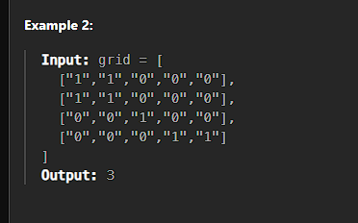
var numIslands = function (grid) {
let row = grid.length;
let col = grid[0].length;
let dx = [1, -1, 0, 0];
let dy = [0, 0, 1, -1];
let count = 0;
for (let i = 0; i < row; i++) {
for (let j = 0; j < col; j++) {
if (grid[i][j] == "1") {
count++;
DFS(grid, i, j);
}
}
}
function DFS(grid, i, j) {
if (i >= 0 && j >= 0 && i < row && j < col && grid[i][j] == "1") {
console.log(i, j);
grid[i][j] = "0";
for (let k = 0; k < 4; k++) {
let x = i + dx[k];
let y = j + dy[k];
DFS(grid, x, y);
}
}
}
return count;
};

Flood Fill
https://leetcode.com/problems/flood-fill/description/
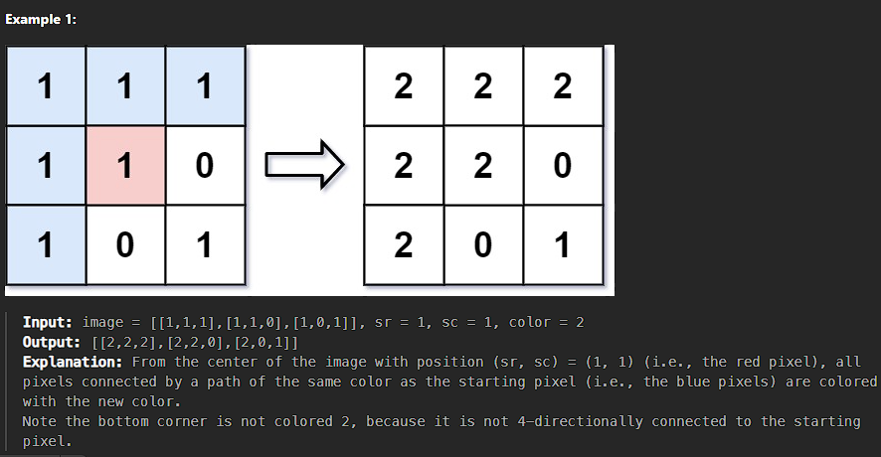
/**
* @param {number[][]} image
* @param {number} sr
* @param {number} sc
* @param {number} newColor
* @return {number[][]}
*/
var floodFill = function (image, sr, sc, newColor) {
let row = image.length;
let col = image[0].length;
let currentColor = image[sr][sc];
if (currentColor == newColor) return image;
let dx = [1, -1, 0, 0];
let dy = [0, 0, 1, -1];
DFS(image, sr, sc);
return image;
function DFS(grid, i, j) {
console.log(i, j);
if (
i >= 0 &&
j >= 0 &&
i < row &&
j < col &&
grid[i][j] == currentColor
) {
grid[i][j] = newColor;
for (let k = 0; k < 4; k++) {
let x = i + dx[k];
let y = j + dy[k];
DFS(grid, x, y);
}
}
}
};

Max Area of Island
https://leetcode.com/problems/max-area-of-island/
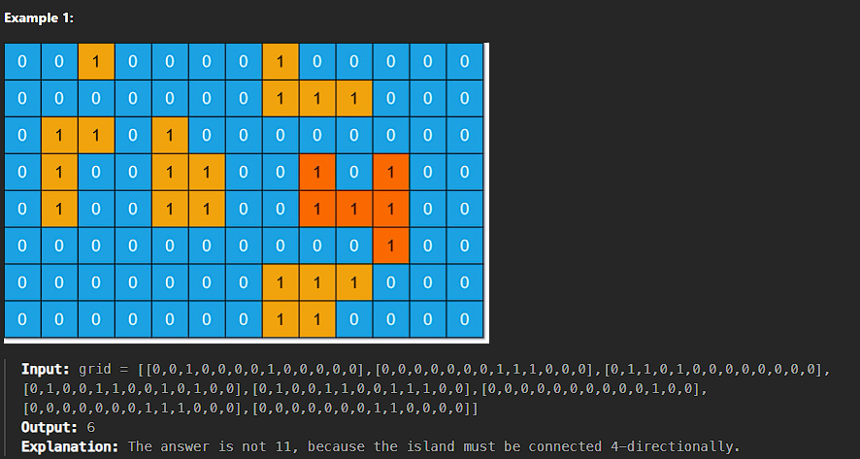
/**
* @param {number[][]} grid
* @return {number}
*/
var maxAreaOfIsland = function (grid) {
let row = grid.length;
let col = grid[0].length;
let dx = [1, -1, 0, 0];
let dy = [0, 0, -1, 1];
let maxCount = 0;
let count = 1;
for (let i = 0; i < row; i++) {
for (let j = 0; j < col; j++) {
if (grid[i][j] == 1) {
count = 0;
DFS(grid, i, j);
maxCount = Math.max(maxCount, count);
}
}
}
function DFS(grid, i, j) {
if (i >= 0 && j >= 0 && i < row && j < col && grid[i][j] == 1) {
count = count + 1;
grid[i][j] = "$";
for (let k = 0; k < 4; k++) {
let x = i + dx[k];
let y = j + dy[k];
DFS(grid, x, y);
}
}
}
return maxCount;
};

Surrounded Regions
https://leetcode.com/problems/surrounded-regions/description/
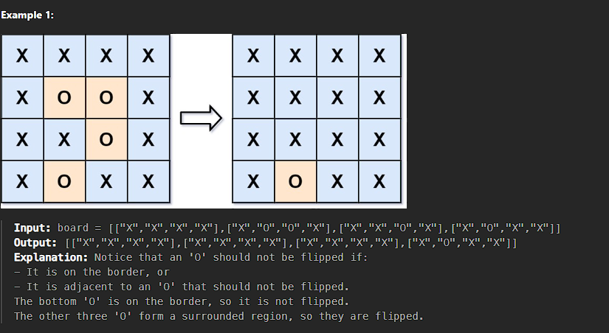
var solve = function (board) {
let grid = board;
let row = board.length;
let col = board[0].length;
let dx = [1, -1, 0, 0];
let dy = [0, 0, 1, -1];
//BOUNDARY dfs TRAVERSALSAL
for (let i = 0; i < row; i++) {
for (let j = 0; j < col; j++) {
if (
(i == 0 || i == row - 1 || j == 0 || j == col - 1) &&
board[i][j] == "O"
) {
Dfs(grid, i, j);
}
}
}
// console.log(grid)
for (let i = 0; i < row; i++) {
for (let j = 0; j < col; j++) {
console.log(grid[i][j]);
//CHANGE TO ANYTHING OTHERTHAN O
if (grid[i][j] == "V") {
grid[i][j] = "O";
// console.log(grid[i][j],"updated")
} else {
grid[i][j] = "X";
}
}
}
console.log(grid);
function Dfs(grid, i, j) {
if (i >= 0 && j >= 0 && i < row && j < col && grid[i][j] == "O") {
grid[i][j] = "V";
for (let k = 0; k < 4; k++) {
let x = i + dx[k];
let y = j + dy[k];
Dfs(grid, x, y);
}
}
}
};

Pacific Atlantic Water Flow
https://leetcode.com/problems/surrounded-regions/description/
/**
* @param {number[][]} heights
* @return {number[][]}
*/
var pacificAtlantic = function (heights) {
let pasific = new Set();
let altan = new Set();
let row = heights.length;
let col = heights[0].length;
let dx = [0, 0, -1, 1];
let dy = [1, -1, 0, 0];
for (let i = 0; i < col; i++) {
DFS(0, i, -1, pasific);
DFS(row - 1, i, -1, altan);
}
for (let i = 0; i < row; i++) {
DFS(i, 0, -1, pasific);
DFS(i, col - 1, -1, altan);
}
let res = [];
for (let i = 0; i < row; i++) {
for (let j = 0; j < col; j++) {
if (pasific.has(`${i}-${j}`) && altan.has(`${i}-${j}`)) {
res.push([i, j]);
}
}
}
return res;
function DFS(i, j, prev, ocean) {
if (!isValid(i, j, prev, ocean)) {
return;
}
ocean.add(`${i}-${j}`);
for (let k = 0; k < 4; k++) {
let x = i + dx[k];
let y = j + dy[k];
DFS(x, y, heights[i][j], ocean);
}
}
function isValid(i, j, prev, visited) {
if (
i >= 0 &&
j >= 0 &&
i < row &&
j < col &&
!visited.has(`${i}-${j}`) &&
heights[i][j] >= prev
)
return true;
return false;
}
};

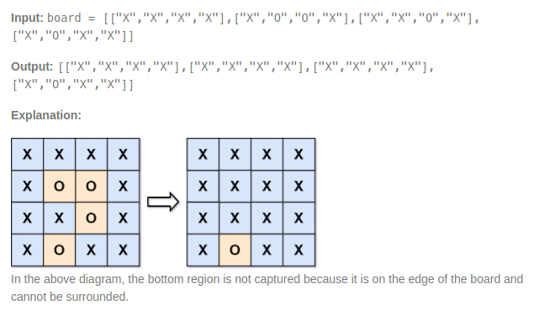

Trie

Implement Trie (Prefix Tree)
https://leetcode.com/problems/implement-trie-prefix-tree/description/
class Trie {
constructor() {
this.root = new Map();
}
insert(word) {
let node = this.root;
for (let c of word) {
if (!node.has(c)) node.set(c, new Map());
node = node.get(c);
}
node.set("isWord", true);
}
traverse(word) {
let node = this.root;
for (let c of word) {
if (!node.has(c)) return null;
node = node.get(c);
}
return node;
}
search(word) {
const node = this.traverse(word);
return node != null && node.has("isWord");
}
startsWith(prefix) {
const node = this.traverse(word);
return node != null;
}
}
// Example usage:
const trie = new Trie();
trie.insert("apple");
console.log(trie.search("apple")); // Output: true
console.log(trie.search("app")); // Output: false
console.log(trie.startsWith("app")); // Output: true
trie.insert("app");
console.log(trie.search("app")); // Output: true

